## *Math for Game Programmers:*

# Solving Nintendo's CodinGame Challenge

## Mike Acton

## [macton@insommiacgames.com](mailto:macton@insommiacgames.com)

## GDC’17

Follow along:  
<https://github.com/macton/nintendo-challenge>

About *process* not solution.

My process. There are other ways of tackling the problem.

Walkthrough the test code and versions created while solving the problem.

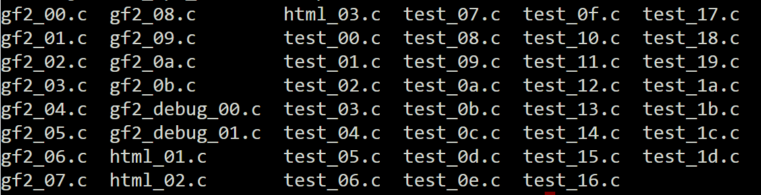

# test_00: test_00.c

What’s the question? Can I get any insight into that?

What’s the problem?

<https://www.codingame.com/ide/puzzle/nintendo-sponsored-contest>

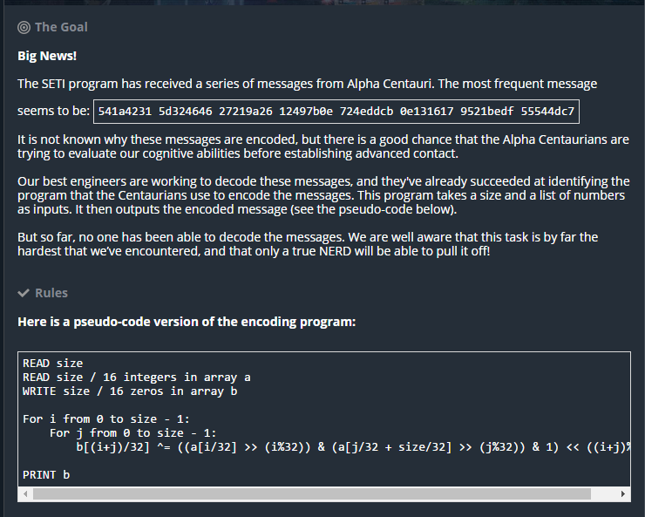

Summarize the problem:

1. B = f(A)
2. Given B and f, return all A which satisfy.
3. Where A and B are 64, 128, 256 or 512 bits.

Call f, “encode”

* B = encode(A)
* {A0,…,An} = decode(B)

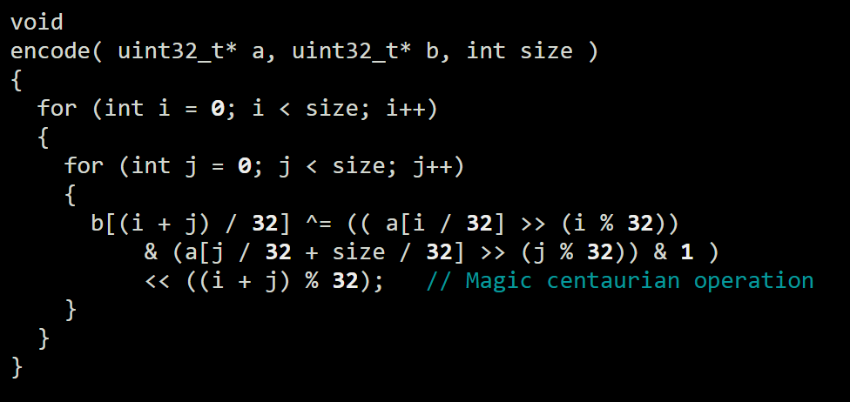

Can assume it’s *possible*.

e.g.

== TEST CASE 4 ==

IN:

64

f3268b49 661859eb 0b324559 65ee6bda

OUT:

0cf5c2bf 9aba68ef c18fb79b de70eef7

c18fb79b de70eef7 0cf5c2bf 9aba68ef

**Q: What does encode do? (before doing anything else try to understand what was given better.)**

Test encode() with random ints

* rand_ints.h: Get random ints from random.org
* test_00.c: print encoded
* 64 bit input/output (but encode takes 32 as parameter?)

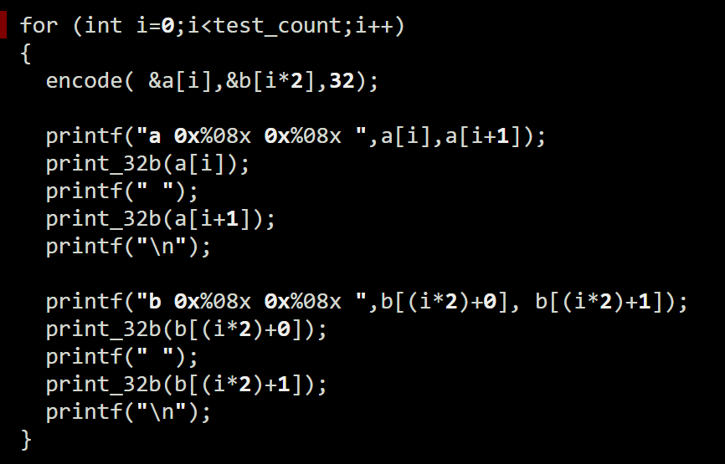

test_00:

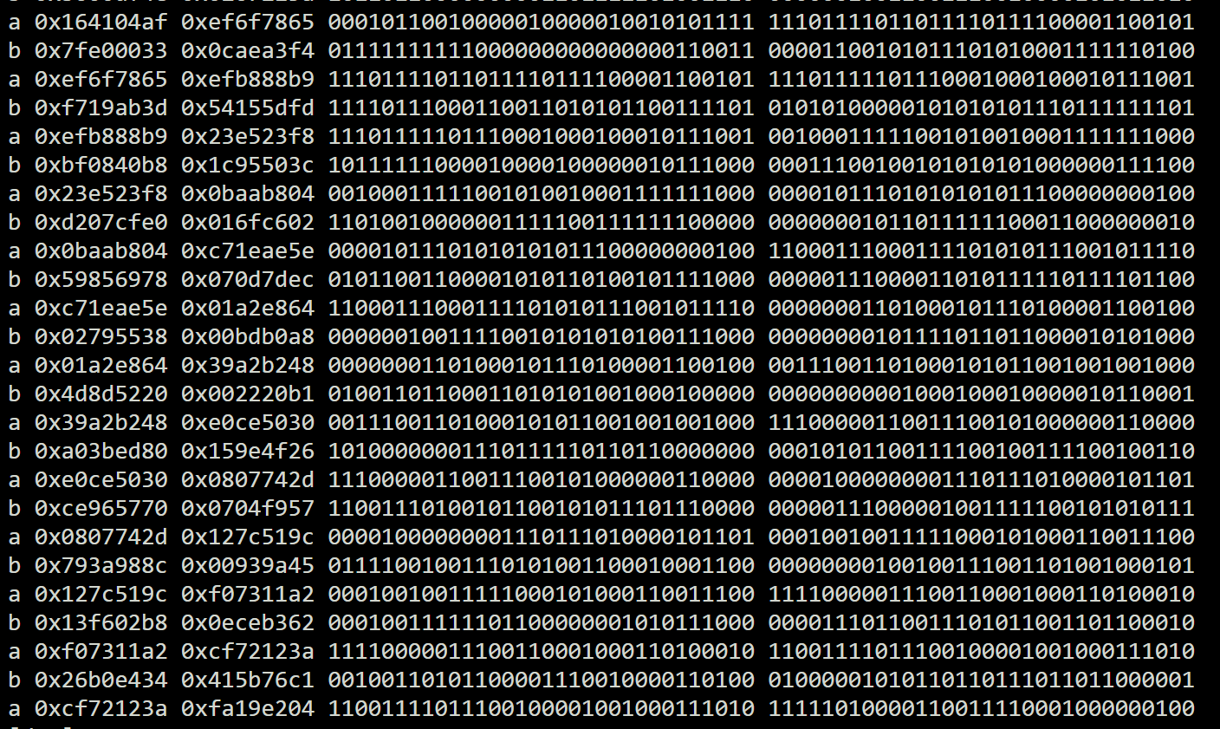

# test_01: test_01.c

Q: Any obvious connection between “encode” input and output?

Test for simple correlation (between bits)

* p(Bn|An) = p(Bn)p(An)/p(An)
* test_01.c : print

test_01.c:

for i=0;i<rand_count;i++

a = rand_uint64[i]

b = encode(a)

for j=0;j<64;j++

if (a&(1<<j)) a_bit_cnt[j]++

if (b&(1<<j)) b_bit_cnt[j]++

for j=0;j<64;j++

p(Bn|An) = (a_bit_cnt[j]*b_bit_cnt[j])/(a_bit_cnt[j]*rand_count)

0: 496 235 0.235235

1: 495 371 0.371371

2: 501 415 0.415415

3: 490 465 0.465465

4: 497 479 0.479479

5: 477 501 0.501502

6: 521 492 0.492492

7: 489 509 0.509510

8: 511 527 0.527528

9: 490 497 0.497497

10: 516 485 0.485485

11: 495 501 0.501502

12: 486 478 0.478478

13: 498 481 0.481481

14: 499 520 0.520521

15: 476 500 0.500501

16: 521 489 0.489489

17: 533 487 0.487487

18: 518 503 0.503504

19: 473 515 0.515516

20: 518 511 0.511512

21: 482 503 0.503504

22: 512 508 0.508509

23: 531 518 0.518519

24: 479 515 0.515516

25: 506 497 0.497497

26: 492 503 0.503504

27: 488 485 0.485485

28: 486 504 0.504505

29: 516 497 0.497497

30: 494 507 0.507508

31: 494 499 0.499499

32: 497 478 0.478478

33: 494 474 0.474474

34: 502 503 0.503504

35: 491 524 0.524525

36: 496 494 0.494494

37: 476 489 0.489489

38: 522 479 0.479479

39: 490 499 0.499499

40: 511 483 0.483483

41: 489 507 0.507508

42: 516 488 0.488488

43: 494 457 0.457457

44: 486 524 0.524525

45: 499 504 0.504505

46: 499 517 0.517518

47: 475 475 0.475475

48: 520 488 0.488488

49: 533 514 0.514515

50: 518 489 0.489489

51: 473 518 0.518519

52: 518 501 0.501502

53: 483 491 0.491491

54: 512 474 0.474474

55: 531 487 0.487487

56: 478 460 0.460460

57: 506 462 0.462462

58: 493 418 0.418418

59: 487 400 0.400400

60: 486 364 0.364364

61: 516 0 0.000000

62: 494 240 0.240240

63: 494 0 0.000000

Middle bits less interesting:

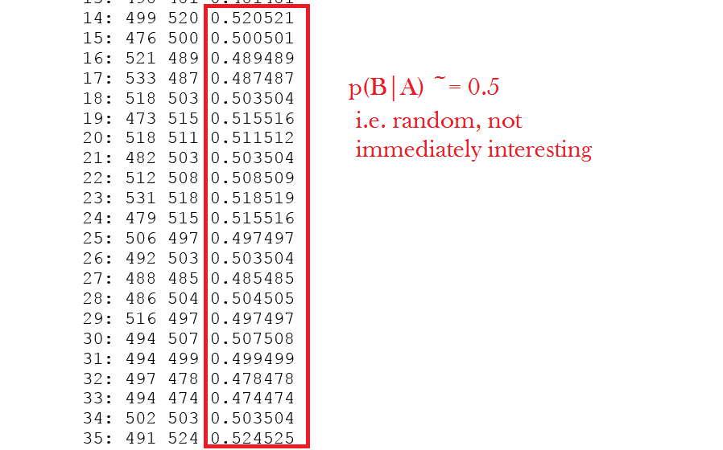

But first few bits, last few bits are interesting.

0: 496 235 0.235235

1: 495 371 0.371371

2: 501 415 0.415415

3: 490 465 0.465465

4: 497 479 0.479479

…

58: 493 418 0.418418

59: 487 400 0.400400

60: 486 364 0.364364

61: 516 0 0.000000

62: 494 240 0.240240

63: 494 0 0.000000

Went off on a tangent: state machine generator

1. What’s needed for the first bit of B to be set.
2. Given the first bit of B, what’s needed for the second bit of B to be set.
3. Etc.

That’s the really long way around this problem!

But then…

# test_02: test_02.c

Argh. Missed an obvious test – recheck with ordered (not random) values...

Test encode() with *ordered* values

* test_02.c : increment input value, print results

for i=0;i<test_count;i++

a = 0xffffffff00000000 | i

b = encode(a)

Sample from test_02:

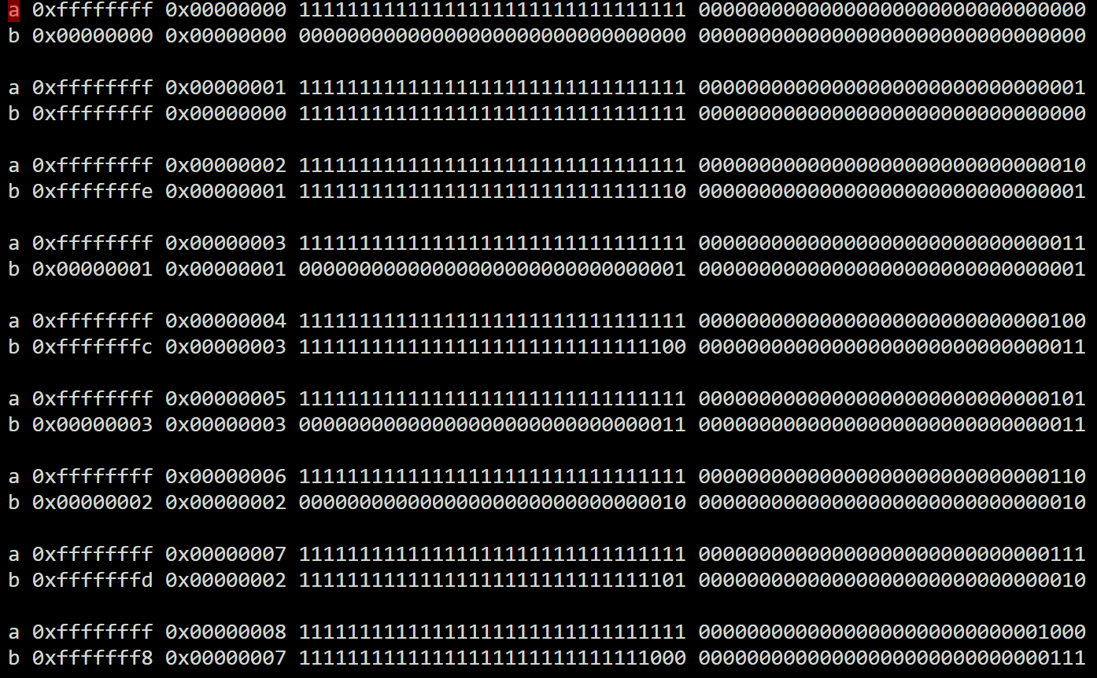

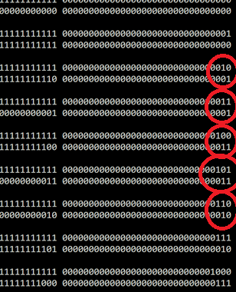

First impression: Something like a gray code?

# test_03: test_03.c

Display output little endian to see if that changes what I see.

Maybe something a little more “natural” for me…

* test_03.c : display little endian

print a[1] a[0]

print b[1] b[0]

instead of…

print a[0] a[1]

print b[0] b[1]

Sample of test_03 output:

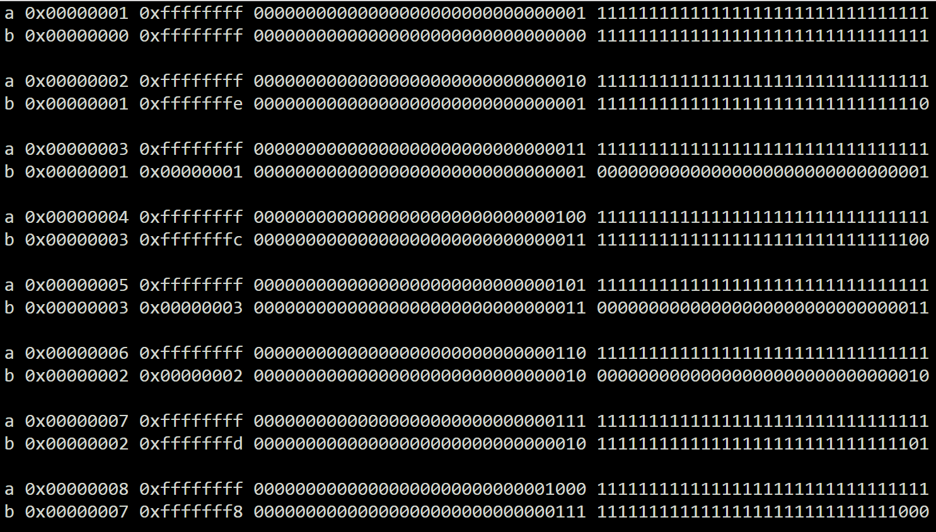

Definitely something in the powers-of-two input values…







# test_04: test_04.c

Print only encode(x) where x is power of two.

Definitely something in the powers-of-two input values…

* test_04.c : print only the powers of two

Sample output from test_04:

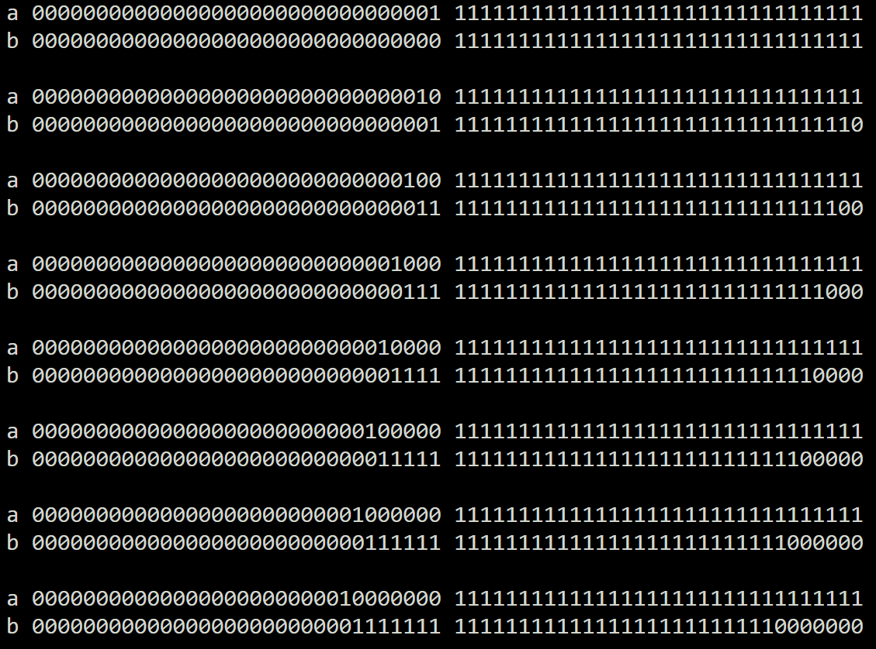

See same pattern in each. Looks like,

a[0]



b = a[0] shift left



b = a[0] shift left by trailing zero count of a[1]



i.e.

uint32_t a[2];

uint64_t b;

if (a[1] & (a[1]-1)) == 0)

{

b = a[0] << ctz(a[1])

}

# test_05: test_05.c

What’s happening when a[1] is *not* a power of two?

Q: What’s happening when a[1] is *not* a power of two?

* test_05.c: Pick single value (0x0f), show along with all results for each power of two in that value.

a = 0xffffffff00000000 | 0x0f

b = encode(a)

a0 = 0xffffffff00000000 | 0x01

b0 = encode(a0)

a1 = 0xffffffff00000000 | 0x02

b1 = encode(a1)

a2 = 0xffffffff00000000 | 0x04

b2 = encode(a2)

a3 = 0xffffffff00000000 | 0x08

b3 = encode(a3)

test_05 output:

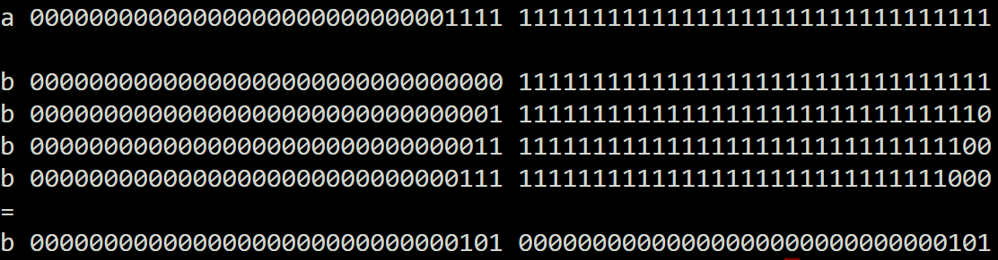

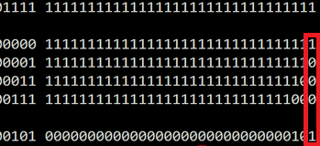

Hmmm. Xor down the columns:

1 ^ 0 ^ 0 ^ 0 = 1

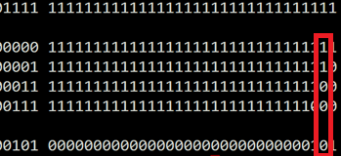

1 ^ 1 ^ 0 ^ 0 = 0

Etc.

Aha! Ok, have a theory!

Where a,b = 64 bits (a[0],b[1] = 32 bits)

uint32_t a[2];

uint64_t b;

b = 0;

for (int i=0;i<32;i++)

{

if (a[0] & (1<<i))

{

b ^= a[1] << i;

}

}

# test_06: test_06.c

Print with different spacing; Just to help myself visualize.

Visualize steps

* test_06.c: same as test_05.c, just different spacing.

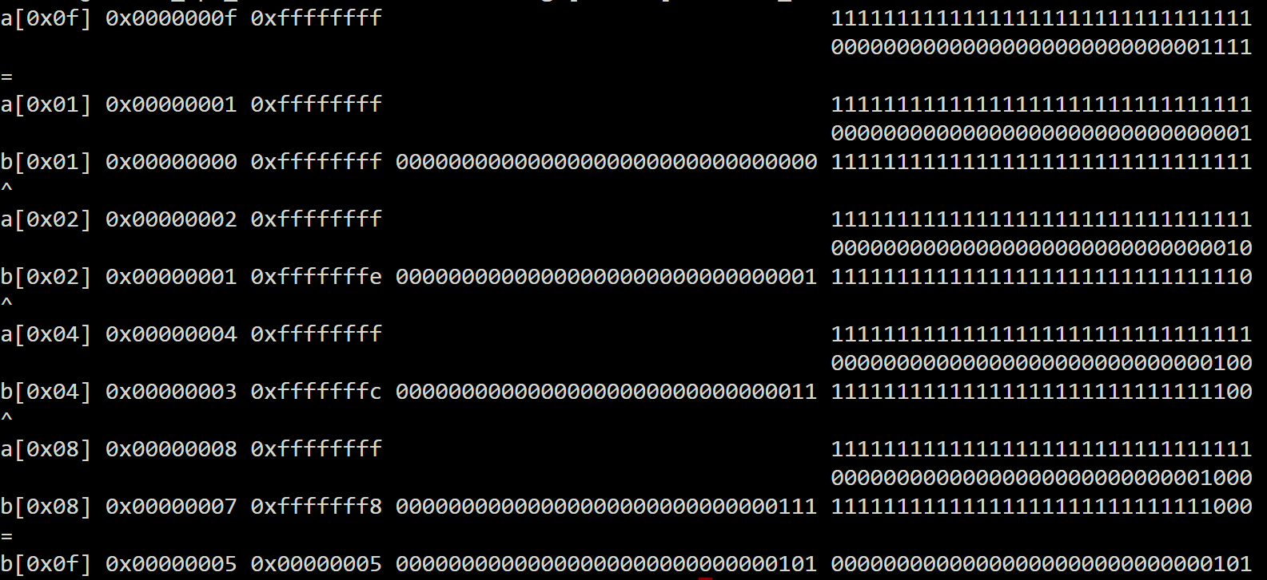

# test_07: test_07.c

Validate across wider sample set. Still make sense?

Up to now,

* a[0] = small subset of values
* a[1] = 0xffffffff

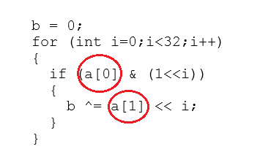

Q: Does the theory hold up across all the sample data?

Q: Does the value of a[0] change things?

* test_07.c: create alternate encode2_32() to compare results against rand_ints

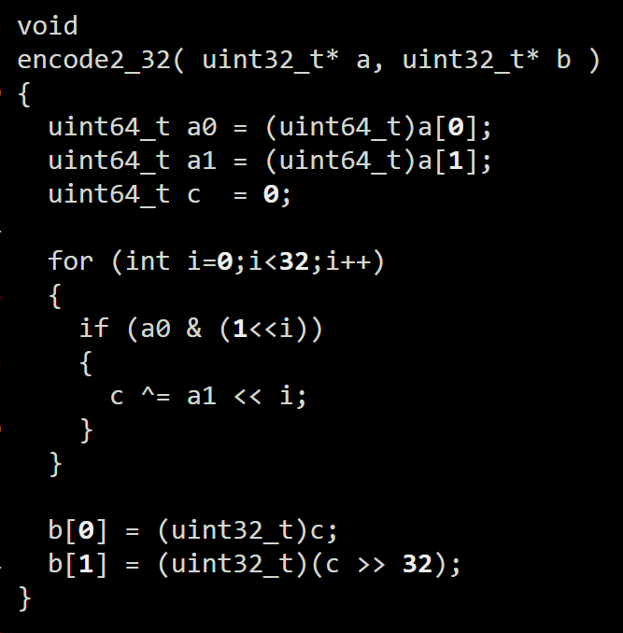

test_07.c:

for i=0;i<rand_count;i++

a = rand_uint64[i]

b0 = encode(a)

b1 = encode2_32(a)

if ( b0 != b1 ) FAIL!

ALL TESTS PASSED!

# test_08: test_08.c

Play with variations of encode.

Reformulate encode2_32()

These are equivalent:

**test_07.c:**

for (int i=0;i<32;i++)

{

if (a0 & (1<<i))

{

c ^= a1 << i;

}

}

**test_08.c:**

for (int i=0;i<32;i++)

{

c ^= (a0 & (1<<i)) * a1;

}

Re-run tests, sanity check:

ALL TESTS PASSED!

# test_09: test_09.c

Go back, revisualize encode with the test inputs.

Re-visualize all the steps against the rand test data.

* Test_09.c : Same as test_07.c but encode2_32() prints steps

Sample of output test_09:

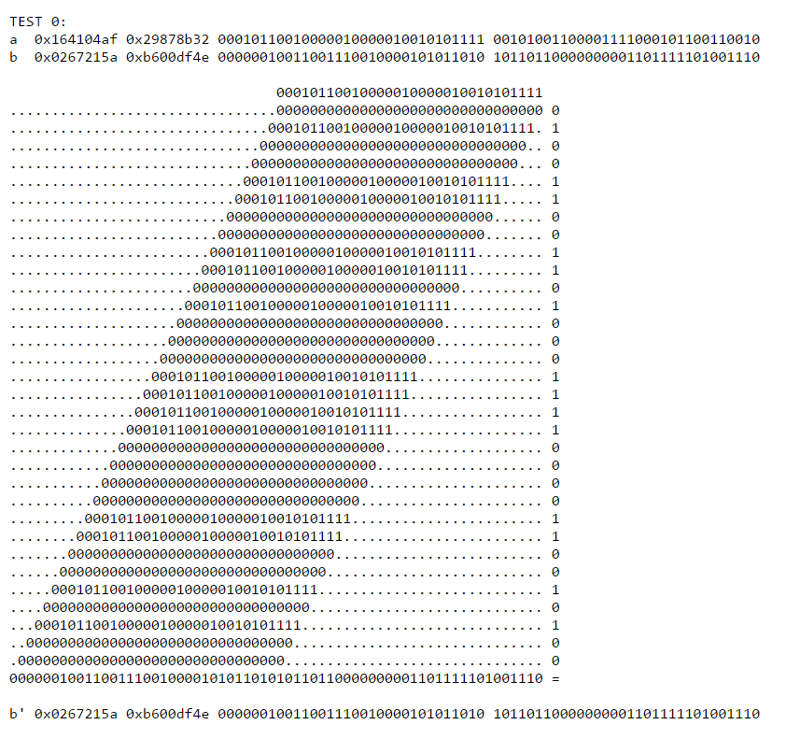

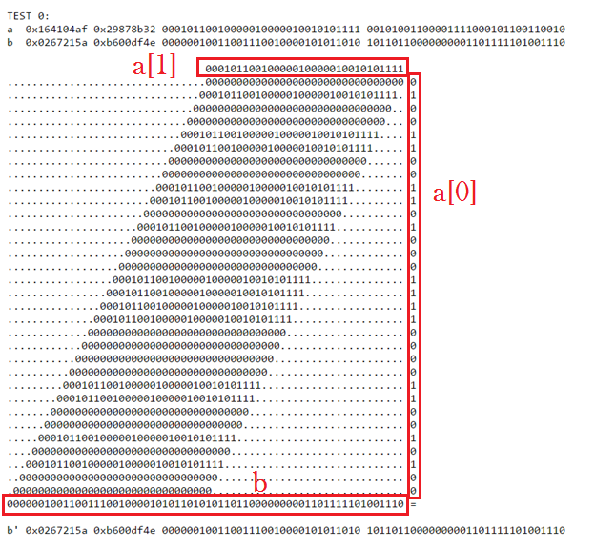

Looks suspiciously like a kind of long-hand multiplication!

But for each place…

* = &

+ = ^

**\* 0 1**

**0** 0 0

**1** 0 1

**+ 0 1**

**0** 0 1

**1** 1 0

Q: What fits this model?

A: multiplication of **polynomial over GF(2)** fits *perfectly***.**

GF = **Galois** (ɡaˈlwa) **Field**

GF(2) = **finite field** of two elements

<https://en.wikipedia.org/wiki/GF(2)>

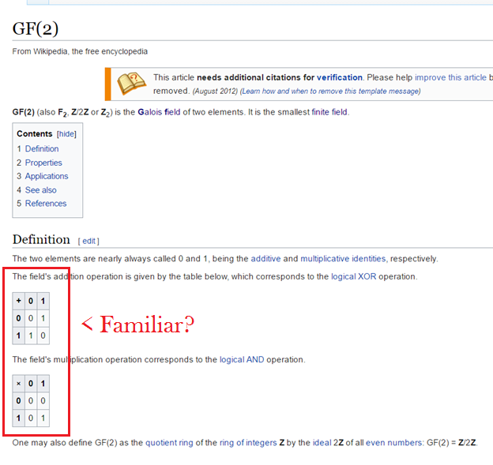

As programmers, we use finite fields all the time.

e.g.

uint8_t a = 0xff;

What is a+2?

i.e.

Just wraps around a certain finite number of things (mod)

GF(2) = All the math is **mod 2**

Nice overview:  
<http://www.math.umn.edu/~garrett/coding/Overheads/08_crcs.pdf>

Q: But what does it mean that it represents a *polynomial* over GF(2)?

1. Exponent is implicit in place
2. Coefficient is stored (can only be one or zero)

e.g.

1011 =

| x^3 | x^2 | x^1 | x^0 |

|-----|-----|-----|-----|

| 1 | 0 | 1 | 1 |

1011 = x^3 + x + 1

# test_0a: test_0a.c gf2_00.c gf2.h

Rewrite encode() in terms of “multiply polynomial over GF(2)” (p_gf2_mul)

Rewrite as gf(2) polynomial multiply

* gf2_00.c
  + p_gf2_mul
  + p_gf2_add
  + p_gf2_sll

p_gf2_mul()

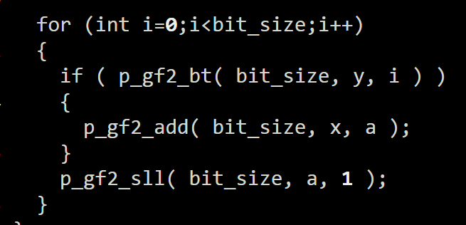

Re-run same tests.

* test_0a.c
  + Same as test_09.c but call p_gf2_mul

ALL TESTS PASSED!

# test_0b: test_0b.c gf2_00.c gf2.h

Sanity test: Do all the expected bit widths work?

So far assumed:

* a[0] = 32 bits
* a[1] = 32 bits
* b = 64 bits

But also need to verify cases where:

* b = 128 bits
* b = 256 bits
* b = 512 bits

test_0b.c

* Same as test_0a.c, but extend tests to above cases.
* Same random values, just interpreted as different sizes

ALL TESTS PASSED!

# test_0c: test_0c.c gf2_01.c gf2.h

Now that I think I know what encode means, what would decode mean?

Q: If encode is p_gf2_mul, what does decode do?   
 i.e. What’s the reverse of multiply?

A: Factor

Have another look at each provided test case…

== TEST CASE 1 ==

IN:

32

000073af 00000000

OUT:

00000001 000073af

00000083 000000e5

000000e5 00000083

000073af 00000001

0x73af = 0x1 x 0x73af

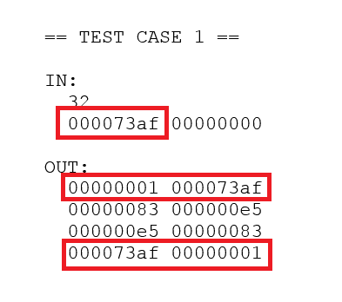

0x73af = 0x83 x 0xe5

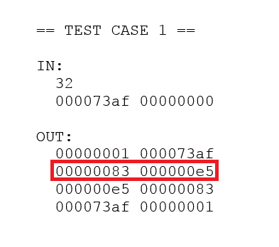

== TEST CASE 2 ==

IN:

32

738377c1 00000000

OUT:

00000001 738377c1

0000b0c5 0000cd55

0000cd55 0000b0c5

738377c1 00000001

== TEST CASE 3 ==

IN:

32

46508fb7 6677e201

OUT:

b0c152f9 ebf2831f

ebf2831f b0c152f9

== TEST CASE 4 ==

IN:

64

f3268b49 661859eb 0b324559 65ee6bda

OUT:

0cf5c2bf 9aba68ef c18fb79b de70eef7

c18fb79b de70eef7 0cf5c2bf 9aba68ef

Some type of multiply/factor should have been obvious to me in the first place from the test data set!

(But I missed it.)

Print test cases as polynomials.

* test_0c.c
  + print all provided test cases
* gf2_01.c
  + add debugging print p_gf2_print

Prints each like:

== TEST CASE 1 ==

IN:

32

x^14 + x^13 + x^12 + x^9 + x^8 + x^7 + x^5 + x^3 + x^2 + x + 1

OUT:

(1) (x^14 + x^13 + x^12 + x^9 + x^8 + x^7 + x^5 + x^3 + x^2 + x + 1)

(x^7 + x + 1) (x^7 + x^6 + x^5 + x^2 + 1)

(x^7 + x^6 + x^5 + x^2 + 1) (x^7 + x + 1)

(x^14 + x^13 + x^12 + x^9 + x^8 + x^7 + x^5 + x^3 + x^2 + x + 1) (1)

**Compare:**

== TEST CASE 1 ==

IN:

32

000073af 00000000

OUT:

00000001 000073af

00000083 000000e5

000000e5 00000083

000073af 00000001

== TEST CASE 1 ==

IN:

32

x^14 + x^13 + x^12 + x^9 + x^8 + x^7 + x^5 + x^3 + x^2 + x + 1

OUT:

(1) (x^14 + x^13 + x^12 + x^9 + x^8 + x^7 + x^5 + x^3 + x^2 + x + 1)

(x^7 + x + 1) (x^7 + x^6 + x^5 + x^2 + 1)

(x^7 + x^6 + x^5 + x^2 + 1) (x^7 + x + 1)

(x^14 + x^13 + x^12 + x^9 + x^8 + x^7 + x^5 + x^3 + x^2 + x + 1) (1)

**Verify (Mathematica):**

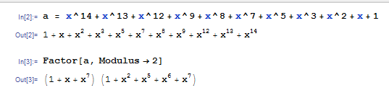

**Verify other test cases:**

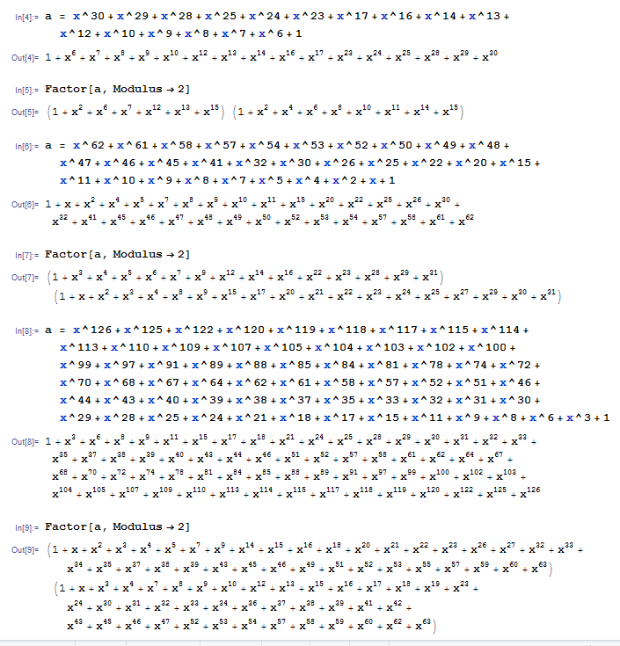

# test_0d: test_0d.c gf2_01.c gf2.h

Start figuring out what decode() would need to do. What’s the process like? What are the steps?

Restate problem:

***Given a polynomial over GF(2^n) where n={64,128,256,512} display all pairs of factors of degree <= n/2***

Q: What if more than two factors?

A: Combine and test for fit.

Step 1: Find all irreducible factors of f

Step 2. Find all (a,b) which satisfy constraints.

Step 3. Format and sort results

Step 4. Output

So… How to factor polynomials over GF(2)?

WWKD?

*What would Knuth do?*

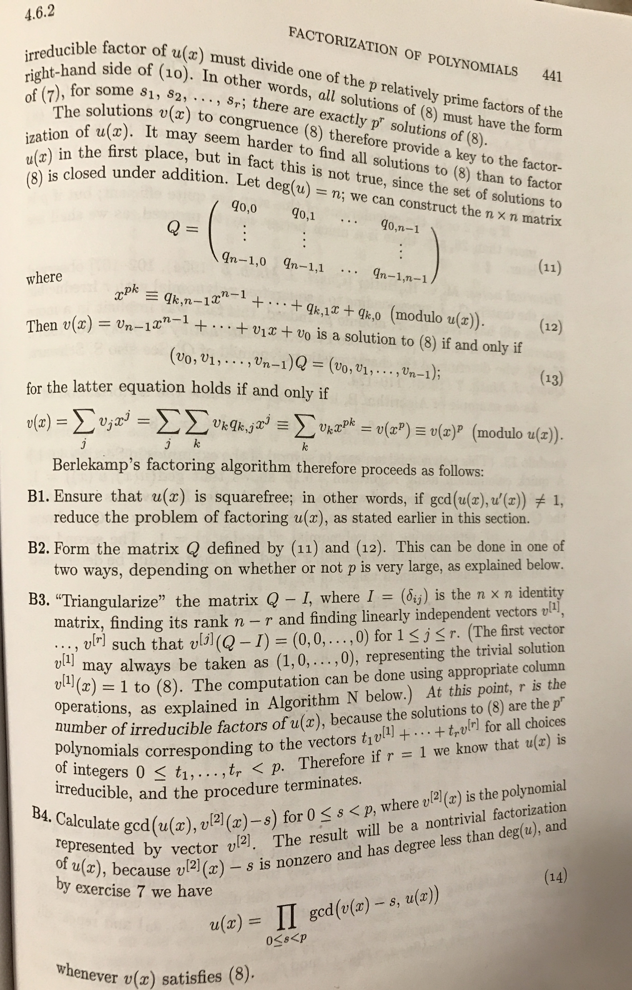

Volume 2 AoCP

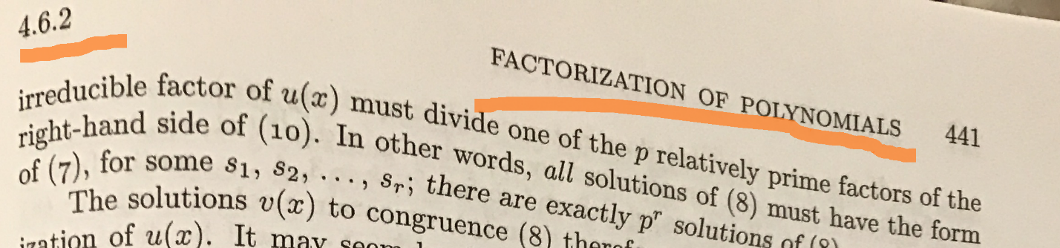

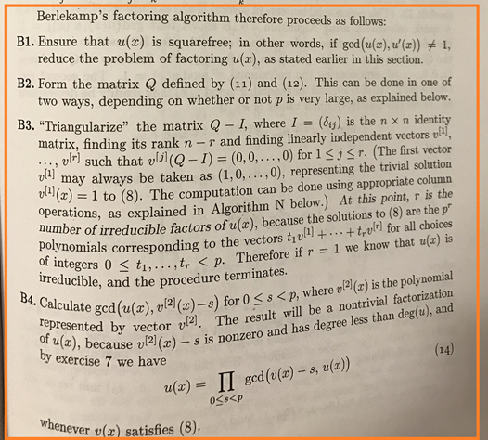

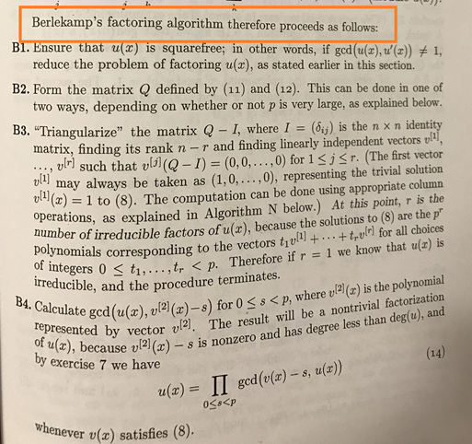



<http://johnkerl.org/doc/iw2009/berlekamp.pdf>

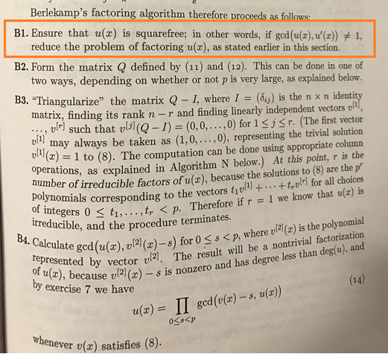

“Ensure that u(x) is squarefree…”

e.g.

a = b^2cd

Pull out squared factors:

a[0] = b^2

a[1] = cd

Square-free Factorization

u(x) has square factor if...

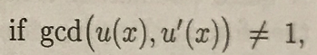

So, to factor out any factor that is a square:

1. f = u(x)
2. f’
3. g=gcd(f,f’)
4. f=gh
5. h=f/g

Create an example with a square in it…

f = b0000110010101110101000111111010001111111111000000000000000110011  
f = 0x0caea3f47fe00033  
f = x59 + x58 + x55 + x53 + x51 + x50 + x49 + x47 + x45 + x41 + x40 + x39 + x38 + x37 + x36 + x34 + x30 + x29 + x28 + x27 + x26 + x25 + x24 + x23 + x22 + x21 + x5 + x4 + x + 1

Verify:

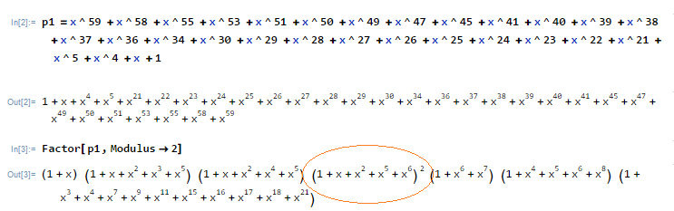

Pull out square factor:

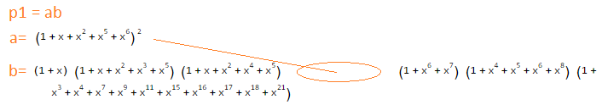

* (1+x) = (0x3)
* (1+x+x^2+x^3+x^5) = (0x2f)
* (1+x+x^2+x^4+x^5) = (0x37)
* (1+x^6+x^7) = (0xc1)
* (1+x^4+x^5+x^6+x^8) = (0x171)
* (1+x^3+x^4+x^7+x^9+x^11+x^15+x^16+x^17+x^18+x^21) = (0x278a99)

Multiply back together.

* test_0d.c: multiply these factors together to get b.

(Already have p_gf2_mul, just another reason to test and verify…)

Get expected result:

b = x^47 + x^46 + x^45 + x^44 + x^42 + x^41 + x^40 + x^39 + x^38 + x^36 + x^35 + x^32 + x^29 + x^26 + x^23 + x^20 + x^19 + x^18 + x^17 + x^16 + x^15 + x^14 + x^13 + x^12 + x^9 + x^8 + x^5 + x^4 + x^3 + x^2 + x + 1

b = 0x249ff33f 0x0000f7d9

**Verify:**

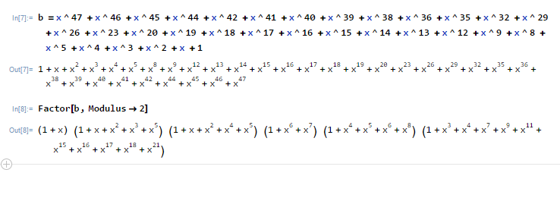

What we should have after SFF:

a = (1 + x + x^2 + x^5 + x^6)^2

b = x^47 + x^46 + x^45 + x^44 + x^42 + x^41 + x^40 + x^39 + x^38 + x^36 + x^35 + x^32 + x^29 + x^26 + x^23 + x^20 + x^19 + x^18 + x^17 + x^16 + x^15 + x^14 + x^13 + x^12 + x^9 + x^8 + x^5 + x^4 + x^3 + x^2 + x + 1

or…

a = (0x67)^2

b = 0x249ff33f 0x0000f7d9

# test_0e: test_0e.c gf2_02.c gf2.h

How to take the derivative of a polynomial in GF(2)?

SFF:

1. f = u(x)
2. f’ <- NEXT STEP
3. g=gcd(f,f’)
4. f=gh
5. h=f/g

Taking the derivative in GF(2)…

Review regular process…

*Derivative of [x^2 + x + 1] with respect to x:*

d/dx [x^2 + x + 1]

1*x^2 + 1*x^1 + 1*x^0

Mechanical steps:

1. Multiply each exponent with coefficient
2. Subtract one from each exponent

(1*2)*x^(2-1) + (1*1)*x^(1-1) + (0*1)*x^(0-1)

= 2x^1 + 1

= 2x + 1

But over GF(2)

* Same mechanical steps, but all math in GF(2) is mod 2.
* So 2 == 0.

*Derivative of [x^2 + x + 1] over GF(2) with respect to x:*

d/dx [x^2 + x + 1] = 1

Taking the derivative in GF(2)...

1. All coefficients are zero or one
2. All even exponents will be multiplied by zero or one to get coefficient
   1. Result coefficient is even or zero.
   2. All even values = 0 (%2)
   3. Mask out all even exponents
3. All odd exponents will be multiplied by zero or one to get coefficient.
   1. Result coefficient is odd or zero
   2. All odd values = 1 (%2)
   3. Reduce all odd exponents by one
   4. Shift right one place odd exponents.

e.g.

(1+x+x^2+x^3+x^5) = (0x2f)

x^5 x^4 x^3 x^2 x 1

1 0 1 1 1 1

Zero even exponents

x^5 x^4 x^3 x^2 x 1

1 - 1 - 1 -

Shift right (remaining odd) exponents

x^5 x^4 x^3 x^2 x 1

.. 1 - 1 - 1 -

d/dx[ 1+x+x^2+x^3+x^5 ] over GF(2) = **x^4 + x^2 + 1**

Witchcraft!



gf2_02.c

* p_gf2_derivative

test_0e.c

* print test

Output of test_0e:

a = x^47 + x^46 + x^45 + x^44 + x^42 + x^41 + x^40 + x^39 + x^38 + x^36 + x^35 + x^32 + x^29 + x^26 + x^23 + x^20 + x^19 + x^18 + x^17 + x^16 + x^15 + x^14 + x^13 + x^12 + x^9 + x^8 + x^5 + x^4 + x^3 + x^2 + x + 1

a' = x^46 + x^44 + x^40 + x^38 + x^34 + x^28 + x^22 + x^18 + x^16 + x^14 + x^12 + x^8 + x^4 + x^2 + 1

(Looks okay…)

# test_0f: test_0f.c gf2_03.c gf2.h

What do I need to find the GCD (Greatest Common Divisor) of two polynomials?

SFF:

1. f = u(x)
2. f’
3. g=gcd(f,f’) <- NEXT STEP
4. f=gh
5. h=f/g

Q: How to GCD of polynomial over GF(2)?

A: Same as GCD of polynomial, only the coefficient math is in GF(2).

Review GCD (Euclid’s Algorithm)

gcd(a,b) = gcd(b,a mod b)

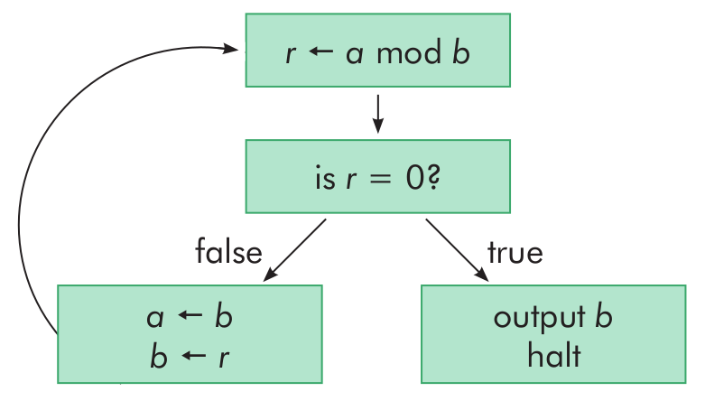

<https://medium.com/great-moments-in-computing-history/euclid-s-ancient-recipe-53e77ba2337c#.xwpnxdpu2>

But (a mod b) (where a and b are polynomials) implies…

Polynomial division over GF(2)

(Mod just remainder after division)

Q: How to divide polynomial over GF(2)?

A: Same as divide polynomial, only the coefficient math is in GF(2).

Review regular polynomial long division:

e.g.

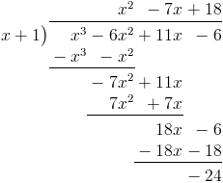

Visualized another way…

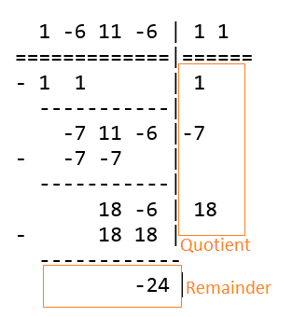

Two operations among coefficients to divide:

1. Multiply
2. Subtract

Multiply coefficients in GF(2) (and):

**\* 0 1**

**0** 0 0

**1** 0 1

Subtraction (mod 2):

0-0 = 0

0-1 = -1 %2 = 1

1-0 = 1

1-1 = 0

Subtract coefficients in GF(2):

**- 0 1**

**0** 0 1

**1** 1 0

Subtraction is same as addition (xor).

test_0f.c

* Print worked example

gf2_03.c

* p_gf2_div
* p_gf2_div_print

Worked example…

c = a/b

a = b00000000000000000001010000010101

a = 0x00001415

a = x^12 + x^10 + x^4 + x^2 + 1

b = b00000000000000000000000001100111

b = 0x00000067

b = x^6 + x^5 + x^2 + x + 1

1010000010101 | 1100111

- 1100111 | 1

------------- |

110111010101 |

- 1100111 | 1

------------- |

100110101 |

- 0000000 | 0

- 0000000 | 0

- 1100111 | 1

------------- |

10101001 |

- 1100111 | 1

------------- |

1100111 |

- 1100111 | 1

------------- |

0 |

a/b = b00000000000000000000000001100111

a/b = 0x00000067

a/b = x^6 + x^5 + x^2 + x + 1

a%b = b00000000000000000000000000000000

a%b = 0x00000000

a%b = 0

p_gf2_div

1. for i=0;i<=count;i++
2. Quotient <<= 1
3. if top bit remainder set
4. Set one to quotient next bit
5. Shift left divisor appropriate amount
6. Subtract from remainder

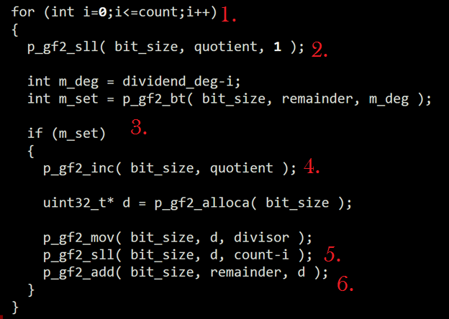

# test_10: test_10.c gf2_03.c gf2.h

Have enough to actually get GCD of two polynomials over GF(2) now…

Return to GCD…

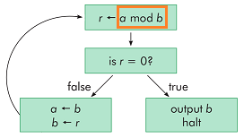

test_10.c

* print gcd(f,f’)

gf2_03.c

* p_gf2_gcd

loop gcd(a,b) = gcd(b,a mod b)

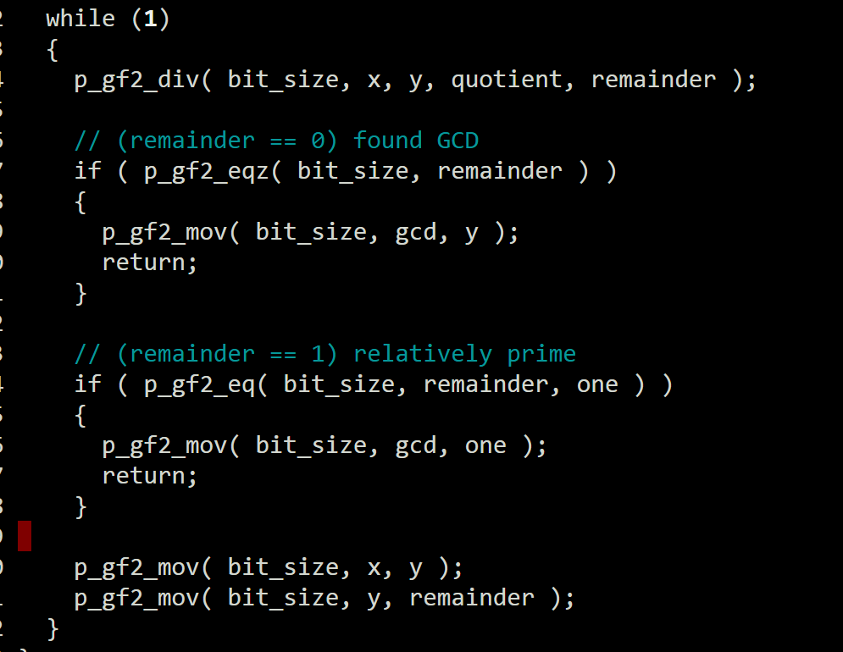

**Output test_10:**

f = b0000110010101110101000111111010001111111111000000000000000110011

f = 0x0caea3f47fe00033

f = x^59 + x^58 + x^55 + x^53 + x^51 + x^50 + x^49 + x^47 + x^45 + x^41 + x^40 + x^39 + x^38 + x^37 + x^36 + x^34 + x^30 + x^29 + x^28 + x^27 + x^26 + x^25 + x^24 + x^23 + x^22 + x^21 + x^5 + x^4 + x + 1

f' = b0000010001010101010100010101000000010101010100000000000000010001

f' = 0x0455515015500011

f' = x^58 + x^54 + x^52 + x^50 + x^48 + x^46 + x^44 + x^40 + x^38 + x^36 + x^28 + x^26 + x^24 + x^22 + x^20 + x^4 + 1

gcd = b0000000000000000000000000000000000000000000000000001010000010101

gcd = 0x0000000000001415

gcd = x^12 + x^10 + x^4 + x^2 + 1

**Verify:**

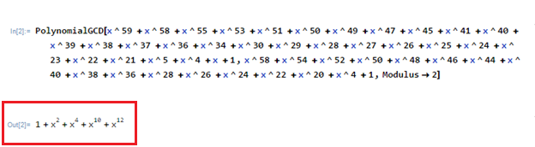

# test_11: test_11.c gf2_04.c gf2.h

Have all the parts to do square-free factorization.

SFF:

1. f = u(x)
2. f’
3. g=gcd(f,f’)
4. f=gh <- OK
5. h=f/g <- OK

gf2_04.c

* p_gf2_sff

test_11.c

* print square-free factors

Output test_11:

a = b0000110010101110101000111111010001111111111000000000000000110011

a = 0x0caea3f47fe00033

a = x^59 + x^58 + x^55 + x^53 + x^51 + x^50 + x^49 + x^47 + x^45 + x^41 + x^40 + x^39 + x^38 + x^37 + x^36 + x^34 + x^30 + x^29 + x^28 + x^27 + x^26 + x^25 + x^24 + x^23 + x^22 + x^21 + x^5 + x^4 + x + 1

sff(a) = = b0000110010101110101000111111010001111111111000000000000000110011

sff(a) = = 0x0caea3f47fe00033

sff(a) = = x^59 + x^58 + x^55 + x^53 + x^51 + x^50 + x^49 + x^47 + x^45 + x^41 + x^40 + x^39 + x^38 + x^37 + x^36 + x^34 + x^30 + x^29 + x^28 + x^27 + x^26 + x^25 + x^24 + x^23 + x^22 + x^21 + x^5 + x^4 + x + 1

sff(a,0) = (x^6 + x^5 + x^2 + x + 1)^2

sff(a,1) = x^47 + x^46 + x^45 + x^44 + x^42 + x^41 + x^40 + x^39 + x^38 + x^36 + x^35 + x^32 + x^29 + x^26 + x^23 + x^20 + x^19 + x^18 + x^17 + x^16 + x^15 + x^14 + x^13 + x^12 + x^9 + x^8 + x^5 + x^4 + x^3 + x^2 + x + 1

sff(a,0) = (b1100111)^2

sff(a,1) = b111101111101100100100100100111111111001100111111

sff(a,0) = (0x67)^2

sff(a,1) = 0xf7d9249ff33f

**Q: Is this what we expected?**

(from test_0d) What we should have after SFF:

a = (1 + x + x^2 + x^5 + x^6)^2

b = x^47 + x^46 + x^45 + x^44 + x^42 + x^41 + x^40 + x^39 + x^38 + x^36 + x^35 + x^32 + x^29 + x^26 + x^23 + x^20 + x^19 + x^18 + x^17 + x^16 + x^15 + x^14 + x^13 + x^12 + x^9 + x^8 + x^5 + x^4 + x^3 + x^2 + x + 1

or…

a = (0x67)^2

b = 0x249ff33f 0x0000f7d9

# test_12: test_12.c gf2_05.c gf2.h

Build matrix Q described in step B2.

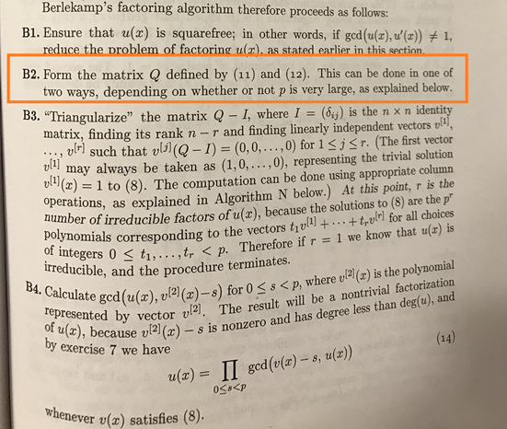

Re: The “explained below…”



To summarize results:



for i=0;i<degree(p);i++

Q[i] = x^(i*2) mod p

*Where degree(p) = largest exponent of p.*

Example from <http://johnkerl.org/doc/iw2009/berlekamp.pdf>

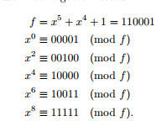

00001 <- Matrix Q where f = x^5 + x^4 + 1

00100

10000

10011

11111

test_12.c

* Verify same results from Kerl’s example.

a = b00000000000000000000000000110001

a = 0x00000031

a = x^5 + x^4 + 1

Q = x^0 mod a = 0000000001 mod a = 00001

x^2 mod a = 0000000100 mod a = 00100

x^4 mod a = 0000010000 mod a = 10000

x^6 mod a = 0001000000 mod a = 10011

x^8 mod a = 0100000000 mod a = 11111

Same!

# test_13: test_13.c gf2_05.c gf2.h

Create a small test example to factor and solve.

Start with a simple example with two irreducible factors to verify as we go:

(1+x+x^2+x^4+x^5) = (0x37)

(1+x^6+x^7) = (0xc1)

Multiply together:

a = (1+x+x^2+x^4+x^5)(1+x^6+x^7)

a = (0x37)(0xc1)

test_13.c

* Multiply and print this example

Start with known irreducible factors (a0,a1)...

a0 = b00000000000000000000000000110111

a0 = 0x00000037

a0 = x^5 + x^4 + x^2 + x + 1

a1 = b00000000000000000000000011000001

a1 = 0x000000c1

a1 = x^7 + x^6 + 1

a = a0 * a1

a = b00000000000000000001011001110111

a = 0x00001677

a = x^12 + x^10 + x^9 + x^6 + x^5 + x^4 + x^2 + x + 1

# test_14: test_14.c gf2_05.c gf2.h

Start breaking down step B3.

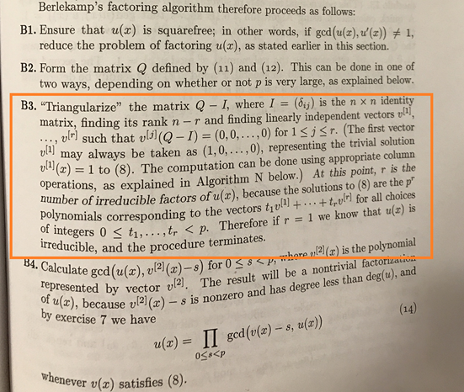

**B3 Summary**

1. M = Q-I
2. Find null basis vectors of M

**B3:**

1. M = Q-I
2. Find null basis vectors of M

test_14.c

* Print Q, I, M (for example from test_13)

a = b00000000000000000001011001110111

a = 0x00001677

a = x^12 + x^10 + x^9 + x^6 + x^5 + x^4 + x^2 + x + 1

Q = 000000000000000000000001 mod a = 000000000001

000000000000000000000100 mod a = 000000000100

000000000000000000010000 mod a = 000000010000

000000000000000001000000 mod a = 000001000000

000000000000000100000000 mod a = 000100000000

000000000000010000000000 mod a = 010000000000

000000000001000000000000 mod a = 011001110111

000000000100000000000000 mod a = 111110101011

000000010000000000000000 mod a = 010000110101

000001000000000000000000 mod a = 011010100011

000100000000000000000000 mod a = 110011111011

010000000000000000000000 mod a = 100101110101

I = 000000000001

000000000010

000000000100

000000001000

000000010000

000000100000

000001000000

000010000000

000100000000

001000000000

010000000000

100000000000

M = 000000000000

000000000110

000000010100

000001001000

000100010000

010000100000

011000110111

111100101011

010100110101

010010100011

100011111011

000101110101

# test_15: test_15.c gf2_06.c gf2.h

What do I need to do to find null basis vectors of matrix M?

**B3:**

1. M = Q-I
2. Find null basis vectors of M

Excellent walkthrough here: [http://math.stackexchange.com/questions/1612616/how-to-find-null-space-basis-directly-by-matrix-calculation/1612994#1612994](http://math.stackexchange.com/questions/1612616/how-to-find-null-space-basis-directly-by-matrix-calculation/1612994)

*(Process like matrix inverse…)*

To summarize:

1. Augment M with identity (I) of same size
2. Transform M to row-reduced echelon form (rref)
3. Null basis vectors are where left side of augmented form is zero.

**B3:**

1. M = Q-I
2. Find null basis vectors of M
   1. Augment M with identity (I) of same size
   2. Transform M to row-reduced echelon form (rref)
   3. Null basis vectors are where left side of augmented form is zero.

W = Augment M with I:

for (i=0;i<degree(p);i++)

W[i] = (M[i] << degree(p)) | (1 << i)

test_15.c

* Create W; Print W

Output:

W = 000000000000 000000000001

000000000110 000000000010

000000010100 000000000100

000001001000 000000001000

000100010000 000000010000

010000100000 000000100000

011000110111 000001000000

111100101011 000010000000

010100110101 000100000000

010010100011 001000000000

100011111011 010000000000

000101110101 100000000000

# test_16: test_16.c gf2_07.c html_01.c gf2.h html.h

Need a function to get matrix M into row-reduced echelon form.

**B3:**

1. M = Q-I
2. Find null basis vectors of M
   1. Augment M with identity (I) of same size
   2. Transform M to row-reduced echelon form (rref)
   3. Null basis vectors are where left side of augmented form is zero.

*Gauss-Jordan Elimination*

* Useful description:  
  <http://pages.pacificcoast.net/~cazelais/251/gauss-jordan.pdf>
* Calculator for reference:   
  <http://matrix.reshish.com/gauss-jordanElimination.php>

rref:

* gf2_07.c
  1. p_gf2_rref
  2. p_gf2_rref_html
* test_16.c
  1. index.html: print all rref steps to verify

Gauss Jordon Elimination over GF(2)

(Same but component

Mark first row (*) as next result row

do {

1. Find first row with leftmost bit set starting from next result row.
2. Swap pivot row and next result row; Increment next result row.
3. Add pivot row to all other rows with bit set in pivot column

} while still have leftmost bits and result columns

Remember “add” is in GF(2) (i.e. xor)

Output test_16:

Transform M into row reduced echelon form (rref)

*Gauss-Jordan Elimination*  
  
Mark first row (*) as next result row

M = * 00000000000000000000000000000001

00000000000000000110000000000010

00000000000000010100000000000100

00000000000001001000000000001000

00000000000100010000000000010000

00000000010000100000000000100000

00000000011000110111000001000000

00000000111100101011000010000000

00000000010100110101000100000000

00000000010010100011001000000000

00000000100011111011010000000000

00000000000101110101100000000000

Highlight next pivot row and column  
*Find first row with leftmost bit set starting from next result row.*

M = * 00000000000000000000000000000001

00000000000000000110000000000010

00000000000000010100000000000100

00000000000001001000000000001000

00000000000100010000000000010000

00000000010000100000000000100000

00000000011000110111000001000000

00000000111100101011000010000000

00000000010100110101000100000000

00000000010010100011001000000000

00000000100011111011010000000000

00000000000101110101100000000000

Swap pivot row and next result row; Increment next result row.

M = 00000000111100101011000010000000

* 00000000000000000110000000000010

00000000000000010100000000000100

00000000000001001000000000001000

00000000000100010000000000010000

00000000010000100000000000100000

00000000011000110111000001000000

00000000000000000000000000000001

00000000010100110101000100000000

00000000010010100011001000000000

00000000100011111011010000000000

00000000000101110101100000000000

Clear pivot column.  
*Add pivot row to all other rows with bit set in pivot column*

M = 00000000111100101011000010000000

* 00000000000000000110000000000010

00000000000000010100000000000100

00000000000001001000000000001000

00000000000100010000000000010000

00000000010000100000000000100000

00000000011000110111000001000000

00000000000000000000000000000001

00000000010100110101000100000000

00000000010010100011001000000000

00000000011111010000010010000000

00000000000101110101100000000000

Highlight next pivot row and column  
*Find first row with leftmost bit set starting from next result row.*

M = 00000000111100101011000010000000

* 00000000000000000110000000000010

00000000000000010100000000000100

00000000000001001000000000001000

00000000000100010000000000010000

00000000010000100000000000100000

00000000011000110111000001000000

00000000000000000000000000000001

00000000010100110101000100000000

00000000010010100011001000000000

00000000011111010000010010000000

00000000000101110101100000000000

Swap pivot row and next result row; Increment next result row.

M = 00000000111100101011000010000000

00000000010000100000000000100000

* 00000000000000010100000000000100

00000000000001001000000000001000

00000000000100010000000000010000

00000000000000000110000000000010

00000000011000110111000001000000

00000000000000000000000000000001

00000000010100110101000100000000

00000000010010100011001000000000

00000000011111010000010010000000

00000000000101110101100000000000

Clear pivot column.  
*Add pivot row to all other rows with bit set in pivot column*

M = 00000000101100001011000010100000

00000000010000100000000000100000

* 00000000000000010100000000000100

00000000000001001000000000001000

00000000000100010000000000010000

00000000000000000110000000000010

00000000001000010111000001100000

00000000000000000000000000000001

00000000000100010101000100100000

00000000000010000011001000100000

00000000001111110000010010100000

00000000000101110101100000000000

Highlight next pivot row and column  
*Find first row with leftmost bit set starting from next result row.*

M = 00000000101100001011000010100000

00000000010000100000000000100000

* 00000000000000010100000000000100

00000000000001001000000000001000

00000000000100010000000000010000

00000000000000000110000000000010

00000000001000010111000001100000

00000000000000000000000000000001

00000000000100010101000100100000

00000000000010000011001000100000

00000000001111110000010010100000

00000000000101110101100000000000

Swap pivot row and next result row; Increment next result row.

M = 00000000101100001011000010100000

00000000010000100000000000100000

00000000001000010111000001100000

* 00000000000001001000000000001000

00000000000100010000000000010000

00000000000000000110000000000010

00000000000000010100000000000100

00000000000000000000000000000001

00000000000100010101000100100000

00000000000010000011001000100000

00000000001111110000010010100000

00000000000101110101100000000000

Clear pivot column.  
*Add pivot row to all other rows with bit set in pivot column*

M = 00000000100100011100000011000000

00000000010000100000000000100000

00000000001000010111000001100000

* 00000000000001001000000000001000

00000000000100010000000000010000

00000000000000000110000000000010

00000000000000010100000000000100

00000000000000000000000000000001

00000000000100010101000100100000

00000000000010000011001000100000

00000000000111100111010011000000

00000000000101110101100000000000

Highlight next pivot row and column  
*Find first row with leftmost bit set starting from next result row.*

M = 00000000100100011100000011000000

00000000010000100000000000100000

00000000001000010111000001100000

* 00000000000001001000000000001000

00000000000100010000000000010000

00000000000000000110000000000010

00000000000000010100000000000100

00000000000000000000000000000001

00000000000100010101000100100000

00000000000010000011001000100000

00000000000111100111010011000000

00000000000101110101100000000000

Swap pivot row and next result row; Increment next result row.

M = 00000000100100011100000011000000

00000000010000100000000000100000

00000000001000010111000001100000

00000000000100010000000000010000

* 00000000000001001000000000001000

00000000000000000110000000000010

00000000000000010100000000000100

00000000000000000000000000000001

00000000000100010101000100100000

00000000000010000011001000100000

00000000000111100111010011000000

00000000000101110101100000000000

Clear pivot column.  
*Add pivot row to all other rows with bit set in pivot column*

M = 00000000100000001100000011010000

00000000010000100000000000100000

00000000001000010111000001100000

00000000000100010000000000010000

* 00000000000001001000000000001000

00000000000000000110000000000010

00000000000000010100000000000100

00000000000000000000000000000001

00000000000000000101000100110000

00000000000010000011001000100000

00000000000011110111010011010000

00000000000001100101100000010000

Highlight next pivot row and column  
*Find first row with leftmost bit set starting from next result row.*

M = 00000000100000001100000011010000

00000000010000100000000000100000

00000000001000010111000001100000

00000000000100010000000000010000

* 00000000000001001000000000001000

00000000000000000110000000000010

00000000000000010100000000000100

00000000000000000000000000000001

00000000000000000101000100110000

00000000000010000011001000100000

00000000000011110111010011010000

00000000000001100101100000010000

Swap pivot row and next result row; Increment next result row.

M = 00000000100000001100000011010000

00000000010000100000000000100000

00000000001000010111000001100000

00000000000100010000000000010000

00000000000010000011001000100000

* 00000000000000000110000000000010

00000000000000010100000000000100

00000000000000000000000000000001

00000000000000000101000100110000

00000000000001001000000000001000

00000000000011110111010011010000

00000000000001100101100000010000

Clear pivot column.  
*Add pivot row to all other rows with bit set in pivot column*

M = 00000000100000001100000011010000

00000000010000100000000000100000

00000000001000010111000001100000

00000000000100010000000000010000

00000000000010000011001000100000

* 00000000000000000110000000000010

00000000000000010100000000000100

00000000000000000000000000000001

00000000000000000101000100110000

00000000000001001000000000001000

00000000000001110100011011110000

00000000000001100101100000010000

Highlight next pivot row and column  
*Find first row with leftmost bit set starting from next result row.*

M = 00000000100000001100000011010000

00000000010000100000000000100000

00000000001000010111000001100000

00000000000100010000000000010000

00000000000010000011001000100000

* 00000000000000000110000000000010

00000000000000010100000000000100

00000000000000000000000000000001

00000000000000000101000100110000

00000000000001001000000000001000

00000000000001110100011011110000

00000000000001100101100000010000

Swap pivot row and next result row; Increment next result row.

M = 00000000100000001100000011010000

00000000010000100000000000100000

00000000001000010111000001100000

00000000000100010000000000010000

00000000000010000011001000100000

00000000000001001000000000001000

* 00000000000000010100000000000100

00000000000000000000000000000001

00000000000000000101000100110000

00000000000000000110000000000010

00000000000001110100011011110000

00000000000001100101100000010000

Clear pivot column.  
*Add pivot row to all other rows with bit set in pivot column*

M = 00000000100000001100000011010000

00000000010000100000000000100000

00000000001000010111000001100000

00000000000100010000000000010000

00000000000010000011001000100000

00000000000001001000000000001000

* 00000000000000010100000000000100

00000000000000000000000000000001

00000000000000000101000100110000

00000000000000000110000000000010

00000000000000111100011011111000

00000000000000101101100000011000

Highlight next pivot row and column  
*Find first row with leftmost bit set starting from next result row.*

M = 00000000100000001100000011010000

00000000010000100000000000100000

00000000001000010111000001100000

00000000000100010000000000010000

00000000000010000011001000100000

00000000000001001000000000001000

* 00000000000000010100000000000100

00000000000000000000000000000001

00000000000000000101000100110000

00000000000000000110000000000010

00000000000000111100011011111000

00000000000000101101100000011000

Swap pivot row and next result row; Increment next result row.

M = 00000000100000001100000011010000

00000000010000100000000000100000

00000000001000010111000001100000

00000000000100010000000000010000

00000000000010000011001000100000

00000000000001001000000000001000

00000000000000111100011011111000

* 00000000000000000000000000000001

00000000000000000101000100110000

00000000000000000110000000000010

00000000000000010100000000000100

00000000000000101101100000011000

Clear pivot column.  
*Add pivot row to all other rows with bit set in pivot column*

M = 00000000100000001100000011010000

00000000010000011100011011011000

00000000001000010111000001100000

00000000000100010000000000010000

00000000000010000011001000100000

00000000000001001000000000001000

00000000000000111100011011111000

* 00000000000000000000000000000001

00000000000000000101000100110000

00000000000000000110000000000010

00000000000000010100000000000100

00000000000000010001111011100000

Highlight next pivot row and column  
*Find first row with leftmost bit set starting from next result row.*

M = 00000000100000001100000011010000

00000000010000011100011011011000

00000000001000010111000001100000

00000000000100010000000000010000

00000000000010000011001000100000

00000000000001001000000000001000

00000000000000111100011011111000

* 00000000000000000000000000000001

00000000000000000101000100110000

00000000000000000110000000000010

00000000000000010100000000000100

00000000000000010001111011100000

Swap pivot row and next result row; Increment next result row.

M = 00000000100000001100000011010000

00000000010000011100011011011000

00000000001000010111000001100000

00000000000100010000000000010000

00000000000010000011001000100000

00000000000001001000000000001000

00000000000000111100011011111000

00000000000000010100000000000100

* 00000000000000000101000100110000

00000000000000000110000000000010

00000000000000000000000000000001

00000000000000010001111011100000

Clear pivot column.  
*Add pivot row to all other rows with bit set in pivot column*

M = 00000000100000001100000011010000

00000000010000001000011011011100

00000000001000000011000001100100

00000000000100000100000000010100

00000000000010000011001000100000

00000000000001001000000000001000

00000000000000101000011011111100

00000000000000010100000000000100

* 00000000000000000101000100110000

00000000000000000110000000000010

00000000000000000000000000000001

00000000000000000101111011100100

Highlight next pivot row and column  
*Find first row with leftmost bit set starting from next result row.*

M = 00000000100000001100000011010000

00000000010000001000011011011100

00000000001000000011000001100100

00000000000100000100000000010100

00000000000010000011001000100000

00000000000001001000000000001000

00000000000000101000011011111100

00000000000000010100000000000100

* 00000000000000000101000100110000

00000000000000000110000000000010

00000000000000000000000000000001

00000000000000000101111011100100

Increment next result row.

M = 00000000100000001100000011010000

00000000010000001000011011011100

00000000001000000011000001100100

00000000000100000100000000010100

00000000000010000011001000100000

00000000000001001000000000001000

00000000000000101000011011111100

00000000000000010100000000000100

00000000000000000101000100110000

* 00000000000000000110000000000010

00000000000000000000000000000001

00000000000000000101111011100100

Clear pivot column.  
*Add pivot row to all other rows with bit set in pivot column*

M = 00000000100000001001000111100000

00000000010000001000011011011100

00000000001000000011000001100100

00000000000100000001000100100100

00000000000010000011001000100000

00000000000001001000000000001000

00000000000000101000011011111100

00000000000000010001000100110100

00000000000000000101000100110000

* 00000000000000000011000100110010

00000000000000000000000000000001

00000000000000000000111111010100

Highlight next pivot row and column  
*Find first row with leftmost bit set starting from next result row.*

M = 00000000100000001001000111100000

00000000010000001000011011011100

00000000001000000011000001100100

00000000000100000001000100100100

00000000000010000011001000100000

00000000000001001000000000001000

00000000000000101000011011111100

00000000000000010001000100110100

00000000000000000101000100110000

* 00000000000000000011000100110010

00000000000000000000000000000001

00000000000000000000111111010100

Increment next result row.

M = 00000000100000001001000111100000

00000000010000001000011011011100

00000000001000000011000001100100

00000000000100000001000100100100

00000000000010000011001000100000

00000000000001001000000000001000

00000000000000101000011011111100

00000000000000010001000100110100

00000000000000000101000100110000

00000000000000000011000100110010

* 00000000000000000000000000000001

00000000000000000000111111010100

Clear pivot column.  
*Add pivot row to all other rows with bit set in pivot column*

M = 00000000100000001001000111100000

00000000010000001000011011011100

00000000001000000000000101010110

00000000000100000001000100100100

00000000000010000000001100010010

00000000000001001000000000001000

00000000000000101000011011111100

00000000000000010001000100110100

00000000000000000101000100110000

00000000000000000011000100110010

* 00000000000000000000000000000001

00000000000000000000111111010100

Highlight next pivot row and column  
*Find first row with leftmost bit set starting from next result row.*

M = 00000000100000001001000111100000

00000000010000001000011011011100

00000000001000000000000101010110

00000000000100000001000100100100

00000000000010000000001100010010

00000000000001001000000000001000

00000000000000101000011011111100

00000000000000010001000100110100

00000000000000000101000100110000

00000000000000000011000100110010

* 00000000000000000000000000000001

00000000000000000000111111010100

Swap pivot row and next result row; Increment next result row.

M = 00000000100000001001000111100000

00000000010000001000011011011100

00000000001000000000000101010110

00000000000100000001000100100100

00000000000010000000001100010010

00000000000001001000000000001000

00000000000000101000011011111100

00000000000000010001000100110100

00000000000000000101000100110000

00000000000000000011000100110010

00000000000000000000111111010100

* 00000000000000000000000000000001

Clear pivot column.  
*Add pivot row to all other rows with bit set in pivot column*

M = 00000000100000001001000111100000

00000000010000001000011011011100

00000000001000000000000101010110

00000000000100000001000100100100

00000000000010000000001100010010

00000000000001001000000000001000

00000000000000101000011011111100

00000000000000010001000100110100

00000000000000000101000100110000

00000000000000000011000100110010

00000000000000000000111111010100

* 00000000000000000000000000000001

Highlight next pivot row and column  
*Find first row with leftmost bit set starting from next result row.*

M = 00000000100000001001000111100000

00000000010000001000011011011100

00000000001000000000000101010110

00000000000100000001000100100100

00000000000010000000001100010010

00000000000001001000000000001000

00000000000000101000011011111100

00000000000000010001000100110100

00000000000000000101000100110000

00000000000000000011000100110010

00000000000000000000111111010100

* 00000000000000000000000000000001

Increment next result row.

M = 00000000100000001001000111100000

00000000010000001000011011011100

00000000001000000000000101010110

00000000000100000001000100100100

00000000000010000000001100010010

00000000000001001000000000001000

00000000000000101000011011111100

00000000000000010001000100110100

00000000000000000101000100110000

00000000000000000011000100110010

00000000000000000000111111010100

00000000000000000000000000000001

Clear pivot column.  
*Add pivot row to all other rows with bit set in pivot column*

M = 00000000100000001001000111100000

00000000010000001000011011011100

00000000001000000000000101010110

00000000000100000001000100100100

00000000000010000000001100010010

00000000000001001000000000001000

00000000000000101000011011111100

00000000000000010001000100110100

00000000000000000101000100110000

00000000000000000011000100110010

00000000000000000000111111010100

00000000000000000000000000000001

Done.

M = 00000000100000001001000111100000

00000000010000001000011011011100

00000000001000000000000101010110

00000000000100000001000100100100

00000000000010000000001100010010

00000000000001001000000000001000

00000000000000101000011011111100

00000000000000010001000100110100

00000000000000000101000100110000

00000000000000000011000100110010

00000000000000000000111111010100

00000000000000000000000000000001

Result (augmented form):

W = 100000001001 000111100000

010000001000 011011011100

001000000000 000101010110

000100000001 000100100100

000010000000 001100010010

000001001000 000000001000

000000101000 011011111100

000000010001 000100110100

000000000101 000100110000

000000000011 000100110010

000000000000 111111010100

000000000000 000000000001

**Verify:**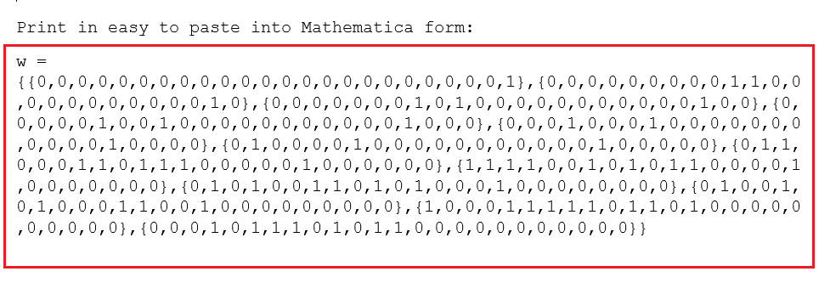Verify with RowReduce[w,Modulus->2]:

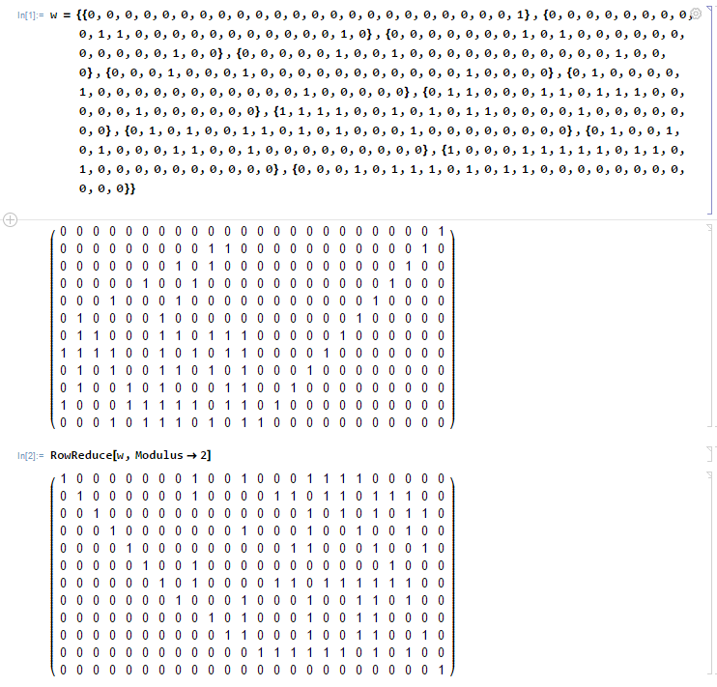

# test_17: test_17.c gf2_07.c html_01.c gf2.h html.h

Highlight the null basis vectors.

**B3:**

1. M = Q-I
2. Find null basis vectors of M
   1. Augment M with identity (I) of same size
   2. Transform M to row-reduced echelon form (rref)
   3. Null basis vectors are where left side of augmented form is zero.

test_17.c

* Just debug print addition. Same as test_16, but highlight null basis vectors in W.

Output test_17:

W in augmented form

W = 010000000100 000111100000

001000000100 011011011100

000100000000 000101010110

000010000000 000100100100

000001000000 001100010010

000000100100 000000001000

000000010100 011011111100

000000001000 000100110100

000000000010 000100110000

000000000001 000100110010

000000000000 111111010100

000000000000 000000000001

Highlight null basis vectors (where left side of row is zero)

W = 010000000100 000111100000

001000000100 011011011100

000100000000 000101010110

000010000000 000100100100

000001000000 001100010010

000000100100 000000001000

000000010100 011011111100

000000001000 000100110100

000000000010 000100110000

000000000001 000100110010

000000000000 111111010100

000000000000 000000000001

Null basis vectors

nv0 = b00000000000000000000111111010100  
nv0 = 0x00000fd4  
nv0 = x11 + x10 + x9 + x8 + x7 + x6 + x4 + x2  
  
nv1 = b00000000000000000000000000000001  
nv1 = 0x00000001  
nv1 = 1

# test_18: test_18.c gf2_08.c html_02.c gf2.h html.h

Complete steps with B4 and apply to simple example.

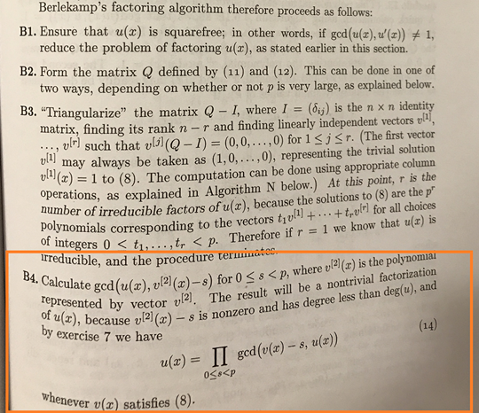

B4 Summary

1. For each non-trivial vector (v) found in B3, find non-trivial factors with:
   1. gcd( f, v )
   2. gcd( f, v-1 )
2. f = gcd( f, v )*gcd( f, v-1 )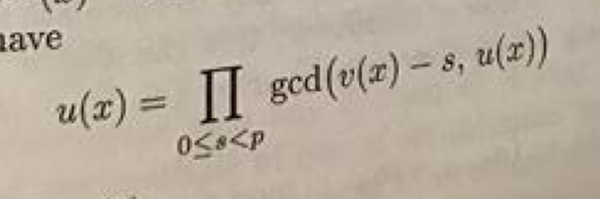

From test_17:

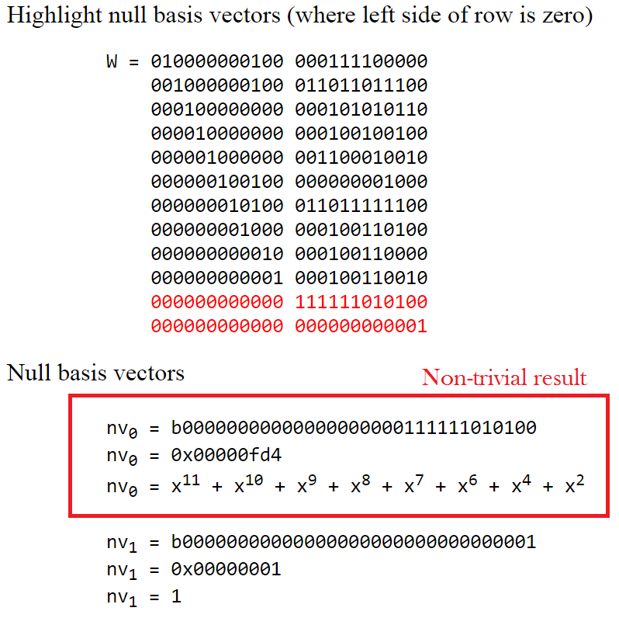

gf2_8.c

* p_gf2_berlekamp_nontrivial_bases: calculation from test_17.c
* filter out trivial one
* p_gf2_berlekamp_nontrivial_bases_html: same, but with html steps output

test_18.c

* Calculate and print:
* gcd( f, v )
* gcd( f, v-1 )
* Verify: f = gcd( f, v )*gcd( f, v-1 )

Results from test_18:

W = 010000000100 000111100000

001000000100 011011011100

000100000000 000101010110

000010000000 000100100100

000001000000 001100010010

000000100100 000000001000

000000010100 011011111100

000000001000 000100110100

000000000010 000100110000

000000000001 000100110010

000000000000 111111010100

000000000000 000000000001

bv[0] = b00000000000000000000111111010100

bv[0] = 0x00000fd4

bv[0] = x^11 + x^10 + x^9 + x^8 + x^7 + x^6 + x^4 + x^2

gcd( a, bv[0]+0 ) = b00000000000000000000000000110111

gcd( a, bv[0]+0 ) = 0x000000**37**

gcd( a, bv[0]+0 ) = **x^5 + x^4 + x^2 + x + 1**

gcd( a, bv[0]+1 ) = b00000000000000000000000011000001

gcd( a, bv[0]+1 ) = 0x000000**c1**

gcd( a, bv[0]+1 ) = **x^7 + x^6 + 1**

Q: Is this what we were looking for?

A: Remember from test_13:

Start with a simple example with two irreducible factors to verify as we go:

(1+x+x^2+x^4+x^5) = (**0x37**)

(1+x^6+x^7) = (**0xc1**)

Yay! Solved a *simple* example.

# test_19: test_19.c gf2_08.c html_02.c gf2.h html.h

Test process on larger (square-free) example made before.

Test on our larger (square-free) example from test_0d:

Remember:

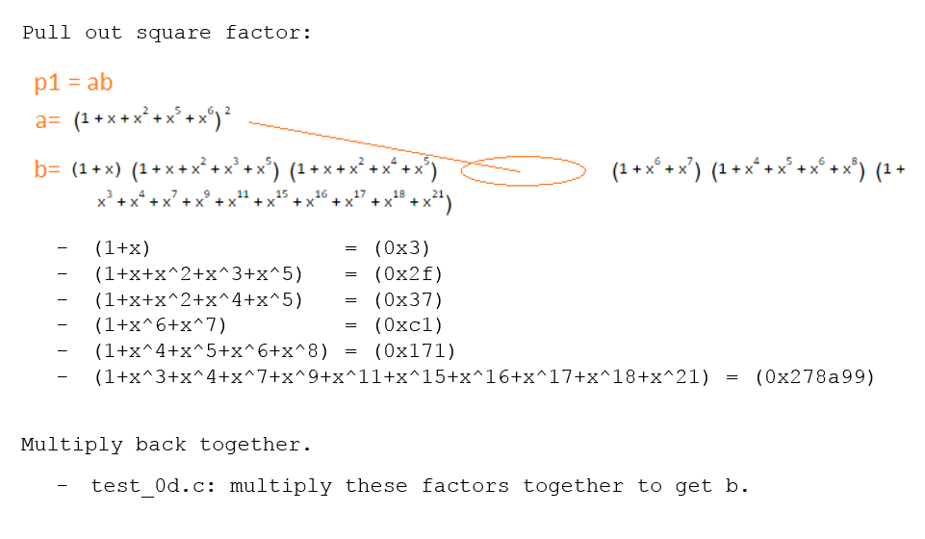

a = b0000000000000000111101111101100100100100100111111111001100111111  
a = 0x0000f7d9249ff33f  
a = x47 + x46 + x45 + x44 + x42 + x41 + x40 + x39 + x38 + x36 + x35 + x32 + x29 + x26 + x23 + x20 + x19 + x18 + x17 + x16 + x15 + x14 + x13 + x12 + x9 + x8 + x5 + x4 + x3 + x2 + x + 1

test_19.c

* Same as test_18.c but with (a), index.html: Print non-trivial factors

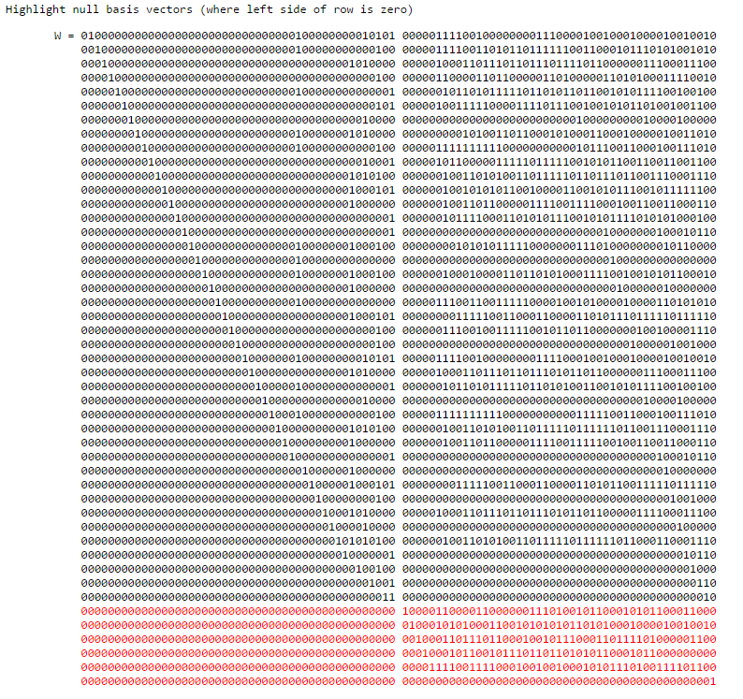

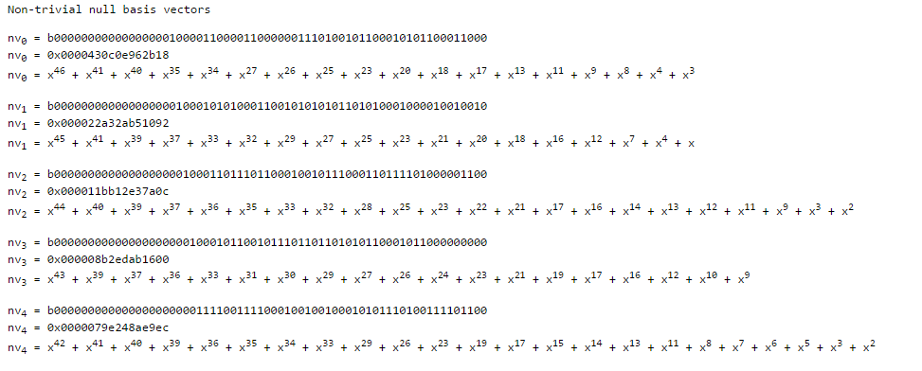

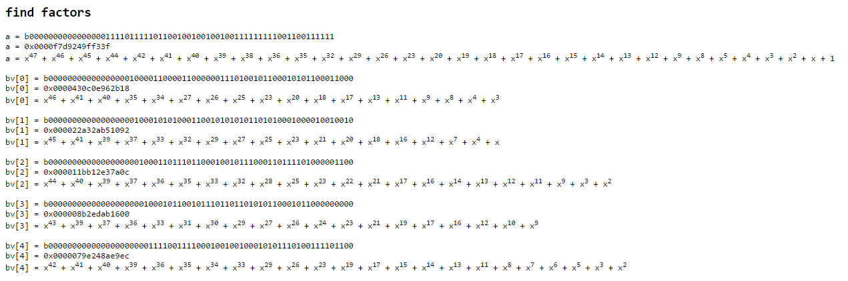

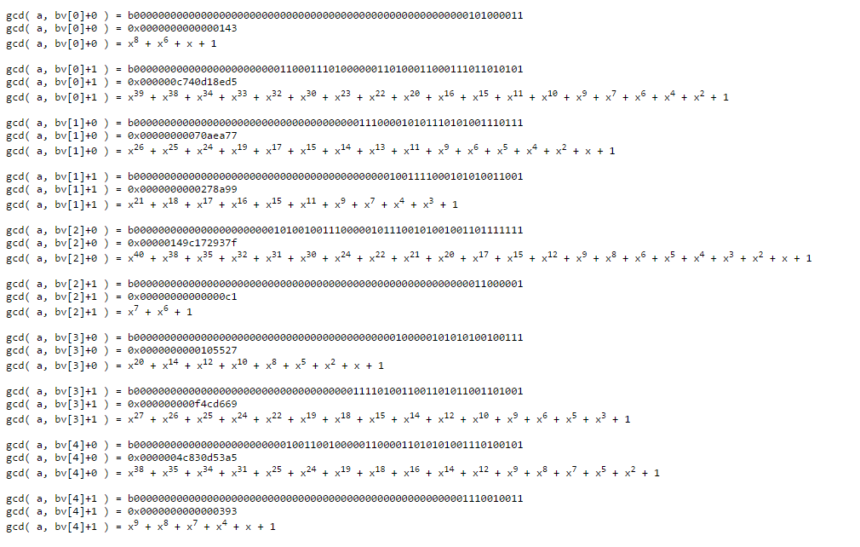

Remember each pair of gcd(f,bv[n])*gcd(f,bv[n]-1) = f

So we can pick any pair, but can we get any more factors out of this list?

# test_1a: test_1a.c gf2_08.c html_02.c gf2.h html.h

From all the potential options, make a list of factors that actually multiply together to make the polynomial.

Stick with the same example:

a = b0000000000000000111101111101100100100100100111111111001100111111  
a = 0x0000f7d9249ff33f  
a = x47 + x46 + x45 + x44 + x42 + x41 + x40 + x39 + x38 + x36 + x35 + x32 + x29 + x26 + x23 + x20 + x19 + x18 + x17 + x16 + x15 + x14 + x13 + x12 + x9 + x8 + x5 + x4 + x3 + x2 + x + 1

Need factors to actually multiply to get a.

test_19.c

* Same as test_18.c, but add steps above to get a list of non-trivial factors which can be multiplied to get a.

For each non-trivial factor (f)

if ( (a%f) == 0 )

a = a / f

add f to list of final non-trivial factors of a

Result from test_1a:

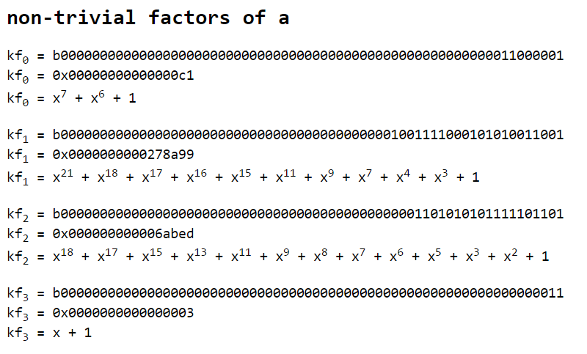

**Non-trivial factors != irreducible factors**

# test_1b: test_1b.c gf2_09.c html_02.c gf2.h html.h

Get list of irreducible factors from list of non-trivial factors.

Q: How to get irreducible factors from non-trivial factors?

A: Recurse!

gf2_09.c

* p_gf2_berlekamp_nontrivial_factors: Calculation from test_1a.c
* p_gf2_berlekamp_nontrivial_factors_html: Same, but output steps to html

test_1b.c

1. For each f in the list of non-trivial factors,
2. Find non-trivial factors of f,
3. Until none can be found.

Results from test_1b:

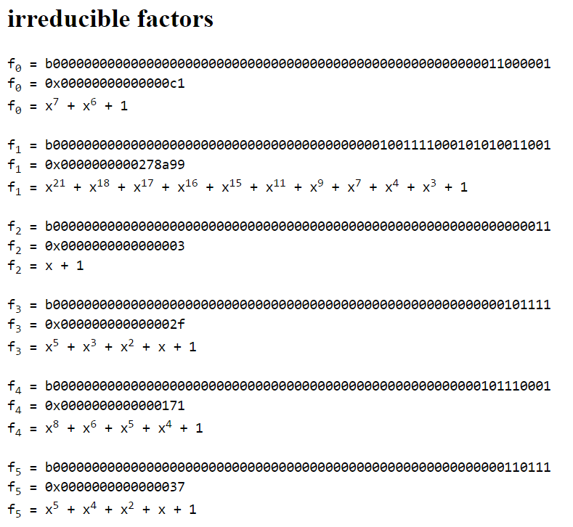

Is this what we expected? (from test_0d):



Yay!

# test_1c: test_1c.c gf2_0a.c gf2_debug_00.c html_03.c gf2.h html.h

Put pieces together and test factor against larger polynomial with squares in it.

Go back to a polynomial with squares in it…

Remember from test_0d:

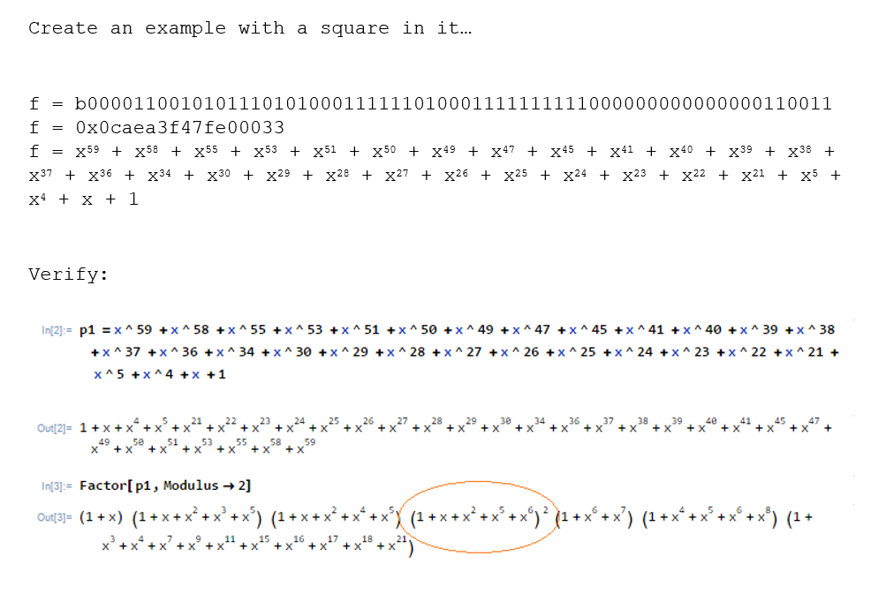

test_1c.c

* call p_gf2_sff first.
* For each square-free factor, same as test_1b.c (find list of irreducible factors)
* Combine to final list.

Results from test_1c

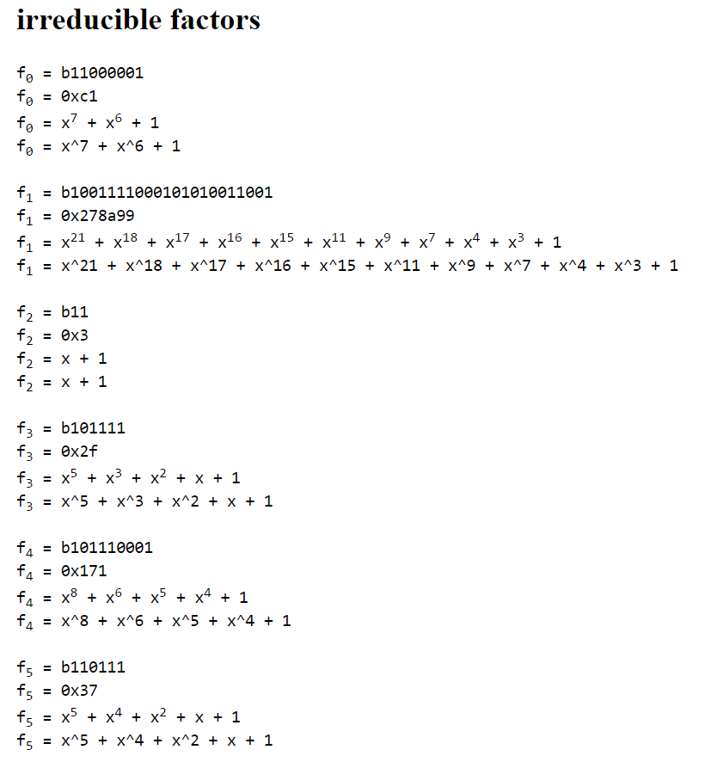

Same!

# test_1d: test_1d.c gf2_0b.c gf2_debug_01.c html_03.c gf2.h html.h

Get expanded list of irreducible factors (duplicate square factors)

From test_1c:



Want to get factors fully expanded.

* Just add to final factor list as many times as exponent.

gf2_0b.c

* p_gf2_factor: Roll in calculation from test_1c.c, duplicate squared factors.
* p_gf2_factor_html: Same but print steps to html

test_1d.c

* Print expanded factors

Output from test_1d:

expanded factors

f0 = b1100111  
f0 = 0x67  
f0 = x6 + x5 + x2 + x + 1  
f0 = x^6 + x^5 + x^2 + x + 1  
  
f1 = b1100111  
f1 = 0x67  
f1 = x6 + x5 + x2 + x + 1  
f1 = x^6 + x^5 + x^2 + x + 1  
  
f2 = b11000001  
f2 = 0xc1  
f2 = x7 + x6 + 1  
f2 = x^7 + x^6 + 1  
  
f3 = b1001111000101010011001  
f3 = 0x278a99  
f3 = x21 + x18 + x17 + x16 + x15 + x11 + x9 + x7 + x4 + x3 + 1  
f3 = x^21 + x^18 + x^17 + x^16 + x^15 + x^11 + x^9 + x^7 + x^4 + x^3 + 1  
  
f4 = b11  
f4 = 0x3  
f4 = x + 1  
f4 = x + 1  
  
f5 = b101111  
f5 = 0x2f  
f5 = x5 + x3 + x2 + x + 1  
f5 = x^5 + x^3 + x^2 + x + 1  
  
f6 = b101110001  
f6 = 0x171  
f6 = x8 + x6 + x5 + x4 + 1  
f6 = x^8 + x^6 + x^5 + x^4 + 1  
  
f7 = b110111  
f7 = 0x37  
f7 = x5 + x4 + x2 + x + 1  
f7 = x^5 + x^4 + x^2 + x + 1

Excellent!

Back to the original problem…

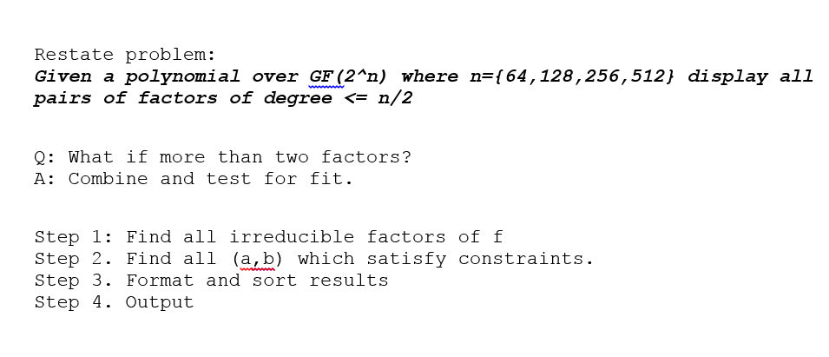

# test_1e: test_1e.c gf2_0b.c gf2_debug_01.c decode_00.c html_03.c gf2.h html.h decode.h

Write complete decode and test result

decode_00.c

* decode
  + Step 2. Find all (a,b) which satisfy constraints.
  + Step 3. Format and sort results
  + Step 4. Output
* decode_html
  + Same as above, but outputs steps to html

test_1e.c

* Same as test_1d, but decode to final output format.

e.g. output:

162fc1f1 edb13c23   
164104af ef6f7865   
1a006059 90a8639b   
28c64f69 7ad664cb   
29b223b9 794ad1bb   
2e00a0eb 7067de89   
7067de89 2e00a0eb   
794ad1bb 29b223b9   
7ad664cb 28c64f69   
90a8639b 1a006059   
edb13c23 162fc1f1   
ef6f7865 164104af

# test_1f: test_1f.c gf2_0b.c gf2_debug_01.c decode_00.c html_03.c gf2.h html.h decode.h

Compare decode against original provided test cases.

test_1f.c

* Run against original test cases.

e.g.

== TEST CASE 3 ==

IN:

32

46508fb7 6677e201

OUT:

b0c152f9 ebf2831f

ebf2831f b0c152f9

Result:

==== TEST 3 ====

b0c152f9 ebf2831f

ebf2831f b0c152f9

OK!

But *sometimes* in the original test cases, the results include an (unnecessary) factor with 1.

== TEST CASE 1 ==

IN:

32

000073af 00000000

OUT:

00000001 000073af

00000083 000000e5

000000e5 00000083

000073af 00000001

Q: When to include the 1 factor in the results?

A: *The solution to that is left as an exercise to the reader. ;)*

## Mike Acton

## [macton@insommiacgames.com](mailto:macton@insommiacgames.com)

## GDC’17

Everything here:  
<https://github.com/macton/nintendo-challenge>